Evolution Study Guide 2

“Evidence for Evolution”

- What are 4 major topics for evidence for evolution?

- How old is life on Earth estimated to be?

- Is the fossil record a complete guide to the history of life? If not why?

- What 3 things does the fossil record tell us?

- What is carbon dating and how can we use it to determine age of things millions of years old?

- What is plate tectonic theory?

- What is biogeography?

- What is the “Wallace’s line”?

- What is adaptive radiation and how can it be used to explain the differences in equestrian (horse) evolution?

- What are homologous structures? Are they from direct ancestral relationships?

- What are vestigial structures?

- What are analogous structures? Are they from direct ancestral relationships?

- What is the difference between convergent and divergent evolution?

- What is embryology?

- What do homeotic genes control?

- What is phylogenetics?

- Who is the closest living ancestor to humans and other apes based off the phylogenetic tree below?
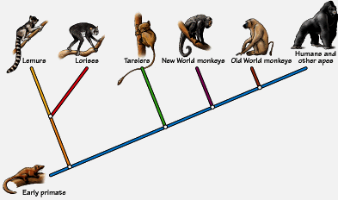

- How can phylogenetics base relatedness from amino acid or DNA sequences?

- What is artificial selection?

- What are some unintending consequences from artificial selection?

- Draw the graphs for the three types of selection below and explain how allelic frequency has changed?

Stabilizing Disruptive Directional

