Evolution, Classification & Microorganisms

Background Information:
Theory- a well-supported testable explanation of phenomena that have occurred in the natural world
Evolution- change over time; modern organisms have descended from ancient organisms.
Darwin’s Theory of Evolution: An adaptation is a trait that helps an organism be more suited to its environment
Darwin decided adaptations develop over time
Natural selection- organisms with traits well suited to their environment survive and reproduce at a greater rate than less well-adapted organisms in the same environment
Long-term survival of any species of organisms is possible only If the organisms can reproduce successfully
Organisms most fit to reproduce are selected by environment which results in adaptation of the population
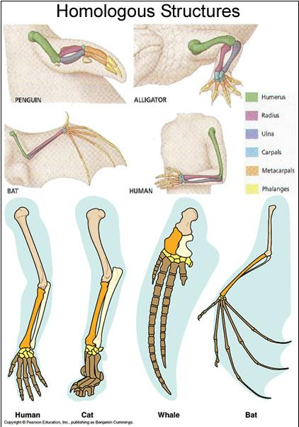
Fitness- ability of an individual to survive and reproduce in its environment
Natural selection is also called “survival of the fittest
Conditions for natural selection include:
A. Genetic variations exist among members of a population
B. Many more individuals are produced each generation than will survive
C. Some individuals are better adapted so they survive and reproduce
D. Members of a population compete for food, space, mates etc.
Common Descent- All species- living and extinct- were derived from common ancestors; Darwin called this “Descent with modification”
Anatomical Evidence of Evolution: Organisms have anatomical similarities when they are closely related because of common descent
- Homologous Structures- in different organisms are inherited from a common ancestor have similar structures (but different function)
EX: vertebrate forelimbs contain the same sets of bones organized in similar ways, despite their dissimilar functions
- Analogous Structures- are inherited from different ancestors and have come to resemble each other because they serve a similar function
EX. Bat wings vs. butterfly wings- both for flight but they are structurally different
- Vestigial Structures- are remains of a structure that have reduced in size because they no longer serve and important function
EX: Humans have a tailbone but no tail EX: Hip/leg bones in pythons and whales, appendix in humans
- Similarities in embryology- the early stages of embryo development in vertebrates show many similarities.
Patterns of Evolution:
1. Adaptive Radiation: A single species or small group of species has evolved, through natural selection and other processes, into diverse forms that live in different ways
2. Convergent Evolution: Unrelated organisms come to resemble one another; Start out with different “raw material” for natural selections; Face similar environmental demands; Natural selection molds similar traits
3. Coevolution- two species evolve in response to changes in each other over time; Organisms closely connected to one another by ecological interactions evolve together; EX: Flowers and pollinators
Endosymbiosis: Most biologists think that mitochondria and chloroplasts were once prokaryotes that formed a partnership with another cell; They contain their own DNA and ribosomes and they reproduce independently of the cells they are in

Analogous Structures:

Natural Selection answer to a similar problem with similar results. The classic example is the wings of bats, birds, and insects. The question, “What structure would best give an organism the opportunity to fly?” The answer… ”wings”. Wings have evolved multiple times over the life’s history thus meaning that birds, bats, and insects DO NOT share a recent common ancestor.

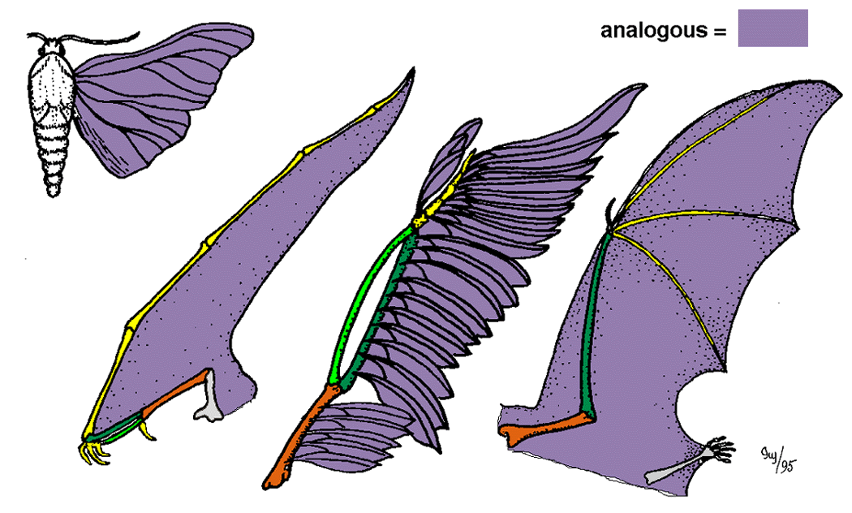

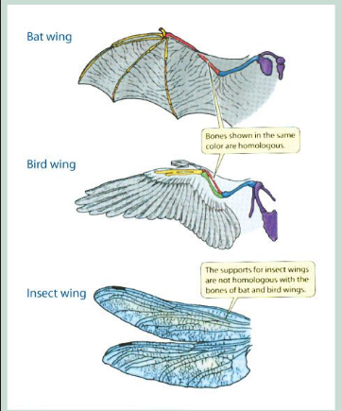

Taxonomy: The science of naming and classifying organisms is called taxonomy.

History of Taxonomy: Aristotle (384-322 B.C.) developed the first widely accepted classification system; He grouped plants and animals into basic categories according to their structural similarities
Binomial Nomenclature: created by Linnaeus: two-word naming system- genus (first word) and species (second word)
Levels of Classification: We have eight levels of classification today. D.K.P.C.O.F.G.S.

Domain Dear

Kingdom King

Phylum Phillip

Class Came

Order Over

Family For

Genus Great

Species Spaghetti

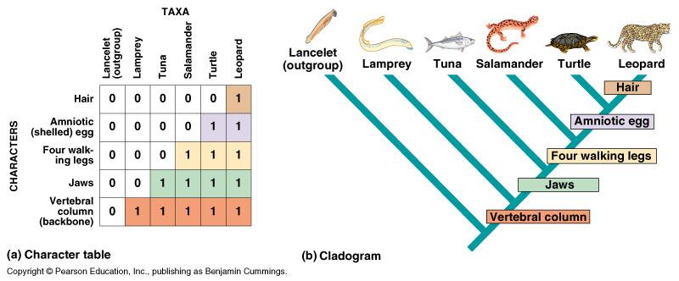
Evolutionary History:

Classification based on similarities often reflects an organism’s phylogeny (evolutionary history).

Similarities that arise due to convergent evolution are called analogous characters

Cladistics is a method of analysis that reconstructs phylogenies by inferring relationships based on shared characters.

There are two types of characters that are used in cladistics

Ancestral Characters - evolved in a common ancestor of both groups

Derived Characters - evolved in an ancestor of one group, but not the other

Biologists use branching diagrams called cladograms to group organisms as well as to separate them.

The Three Domains

1. Bacteria: Contains a single Kingdom (Eubacteria)

2. Archaea: Contains a single Kingdom (Archaeabacteria)

3. Eukarya: Contains 4 diverse Kingdoms (Protista, Fungi, Plantae, and Animalia)

The 4 Ways Organisms are put into a Domain

1. Cell Type: Prokaryotic cells or Eukaryotic cells 2. Cell Walls: Absent or Present

3. Body Type: Unicellular or Multicellular bodies 4. Nutrition: Autrotrophic or Heterotrophic

The Six Kingdoms:

1. Eubacteria

Cell Wall: Eubacteria have cell walls containing peptidoglycan

Gene Translation Apparatus: Their DNA polymerase and ribosomal protein are different than Archaebacteria and Eukaryotes

They can be harmful pathogens useful soil, intestinal, or food bacteria; or even producers!

2. Archaebacteria

Cell Wall and Cell Membrane: Cell Walls do not contain peptidoglycan and their lipids are very different from eubacteria and eukaryotes.

Gene Structure and Translation: Their gene structure and translation process are similar to eukarytoes.

Kinds of Archaebacteria

Methanogens - Live deep within the mud & are poisoned by oxygen… they make methane gas as a waste product.

Extremophiles – Live in extreme environments

Thermophiles - live in very hot places

Halophiles – live in very salty lakes

Domain Eukarya (contains 4 kingdoms)

Highly organized cell interior: The organelles and nucleus allow for specialized function within each cell

Multicellularity: Not all eukaryotes are multicellular, however, all eukaryotic kingdoms have at least a few multicellular members

Sexual Reproduction: Although genetic exchange happens in bacteria, eukaryotes undergo meiosis & more regulated sexual reproduction

3. Protista: “Animal-like” and “Plant-like” organisms most are unicellular BUT a few are multicellular (like kelp); Some make their own food, others do not; They have individuals with similarities to many of the other kingdoms

4. Fungi: Cells walls made with chitin; Most are multicellular BUT some are unicellular; ALL Heterotrophic; Examples: Yeasts & mushrooms

5. Plantae: Cell walls made with cellulose; ALL are multicelluar; ALL are heterotrophic; Nonvascular plants like mosses all the way to daisies and oak trees!

6. Animalia: NO CELL WALLS EVER; ALL multicellular, ALL heterotrophic; from rotifers & earthworms to people
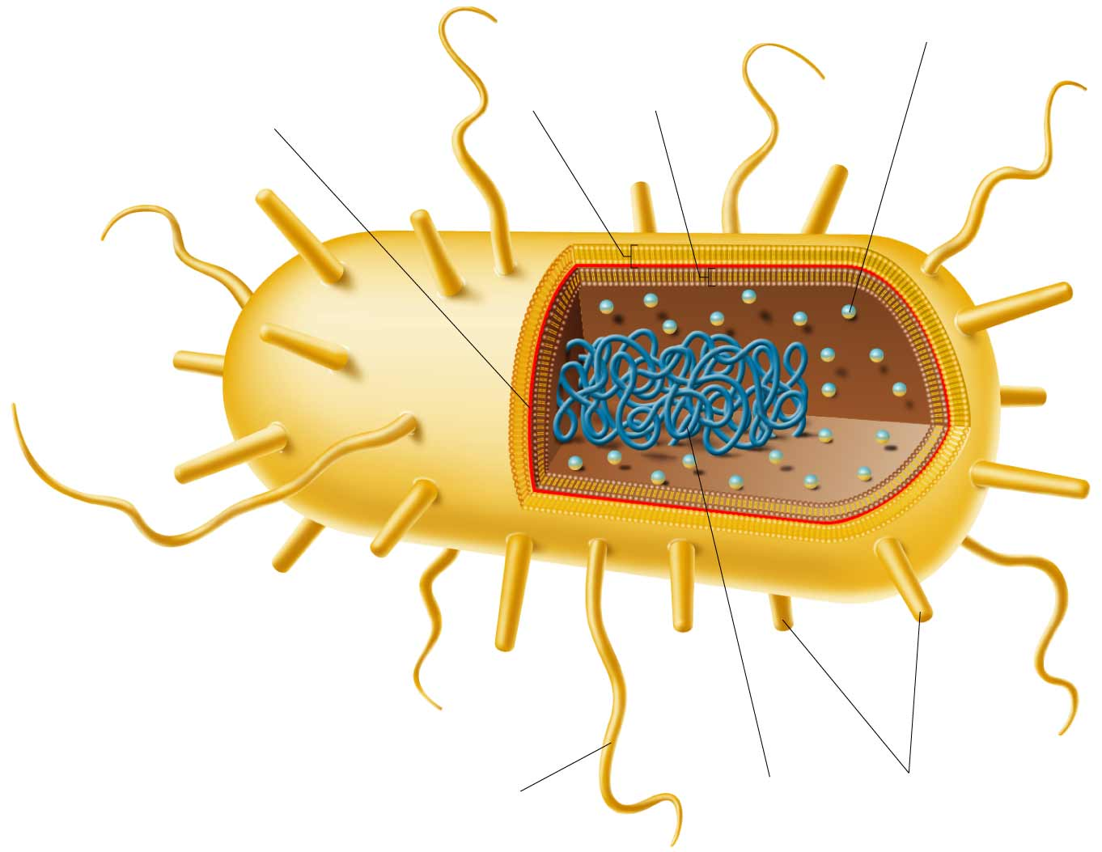
Microorgansims:
Ribosomes

Cell
Membrane

Cell
Wall

Peptidoglycan

Bacteria: ALL PROKARYOTES- do NOT have a nucleus
Two kingdoms: Eubacteria and Archaebacteria
How they are identified: shape, chemical nature of their cell walls, how they move, and how they obtain energy
Shapes: bacilli- rod shaped bacteria; cocci- spherical (round) and spirilla- spiral or corkscrew shaped
Importance of Bacteria- bacteria are vital to maintaining the living world
Flagellum

Some bacteria are producers; produce food through photosynthesis (1st link in food chains)
Others are decomposers; they break down nutrients in dead matter and recycle
Pili

DNA

Nitrogen fixation – bacteria convert nitrogen gas in air to a form plants can use. Bacteria live in root nodules in legume plants (beans)
Human Uses of Bacteria- our bodies are covered in bacteria, some harmful, many are not
E. Coli bacteria in our intestines produce vitamins that our body cannot make. Example of a symbiotic relationship.
Use bacteria for making food – cheese and yogurt
Archaebacteria are used for purifying water (sewage, oil spills)
Bacterial Diseases in Humans:
Bacteria produce disease in 2 ways:
Damage cells & tissues Ex: strep throat, tuberculosis, bubonic plague
Produce toxins Ex: salmonella, botulism
Preventing Bacterial Diseases:
Vaccine - weakened form of bacteria that stimulate the immune system to produce antibodies against the disease.
Antibiotics - compounds that stop bacterial growth. Antibiotics work only on BACTERIAL diseases.

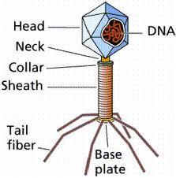
Viruses: particles of nucleic acid (DNA or RNA), proteins, and in some cases, lipids; NOT made of cells; cannot live independently outside of a host, all they do is replicate; a typical virus is composed of a core of DNA or RNA surrounded by a protein coat
Structure: capsid- a virus’s protein coat that helps virus enter host cell
Bacteriophage- virus that infects a bacterium
Lytic Cycle Viral Infection- viral replication cycle in which a virus takes over a host cell’s genetic material and uses the host cell’s structures and energy to replicate until the host cell bursts, killing it
Lysogenic Cycle Viral Infection- viral replication cycle in which a virus’s nucleic acid is integrated into a host cell’s chromosome; the host cell is not killed until the lytic cycle is activated

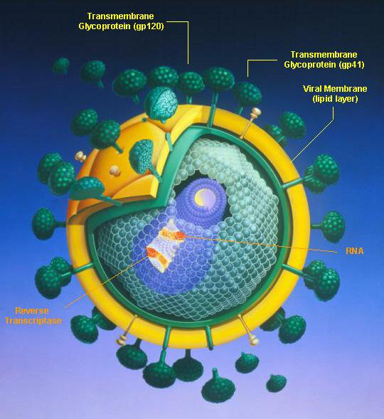
Retroviruses: Contain RNA as their nucleic acid (genetic information), instead of DNA
Called retroviruses because genetic information is copied backwards, from RNA to DNA
Reverse transcriptase- enzyme carried in the capsid of a retrovirus that helps produce viral DNA from viral RNA
The DNA is then integrated into the host cell’s chromosome
Examples include: HIV, some cancers, hepatitis are caused by retroviruses
HIV Virus: Infects helper T cells in the immune system.
HIV can incubate for years, then it will be activated.
AIDS = acquired immunodeficiency syndrome, infected persons cannot fight off other diseases.
Prions: are proteins that cause infections; no nucleic acid to carry genetic info
Viroids are single-stranded RNA molecules that have no capsid (protein coat)

Practice Questions:
1. Structural adaptations help organisms survive in various environments. Which of these is not an example of a structural adaptation?
a. The harmless syrphid fly resembles the yellow jacket in coloring and body shape.
b. The leaf frog’s coloring and shape make camouflage on the forest floor possible.
c. Mole-rats have large teeth and claws which help them dig tunnels and escape predators.
d. A lizard finds a shady spot to escape the sun’s heat.

2. Penicillin is widely used to kill bacteria which cause disease. However, this drug does not affect as many species of bacteria today as it did when it was first discovered. Which statement describing this situation is false?
a. Thousands of years were required for bacteria to become resistant to penicillin.
b. The ability of bacteria to resist penicillin varies within a population.
c. Bacteria which are resistant to penicillin will survive exposure to the drug.
d. Bacteria which are resistant to penicillin will produce penicillin-resistant offspring.

3. Which of the following statements about mutations is false?
a. Environmental factors including radiation and chemicals can cause mutations to occur.
b. Enzymes in cells can fix mutations by replacing incorrect nucleotides with correct ones.
c. All mutations are harmful to both the organism and the species to which it belongs.
d. Cancer is one result of DNA mutation.
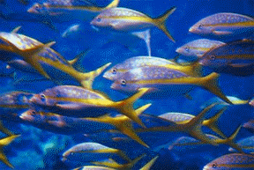
4. Within a fish species, variations exist in color, size, and the speed at which individuals can swim. Which variation would be least likely to be passed on to future generations of the species?
a. swimming speed which is less than that of predators
b. color of markings which aid camouflage
c. size which enables hiding among small rocks and in rock crevices
d. reproduction by laying extremely large numbers of eggs
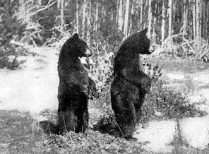

5. A bear produces two offspring. One of the cubs is smaller than normal and has difficulty digesting food. Which statement comparing the two cubs is false?
a. The larger bear cub is more likely to survive to reproductive age.
b. The smaller bear cub is less likely to pass its genes on to another generation.
c. The larger bear is better adapted for survival in its environment.
d. Both bear cubs are equally likely to pass their genes on to the next generation.

6. Which of these statements about natural selection is true?
a. Organisms which survive to reproduce can pass favorable variations on to offspring.
b. Natural selection works on individuals, rather than a population of organisms.
c. All organisms within a species are genetically identical.
d. Offspring can inherit traits of an organism which that organism develops during its life.

7. What is one reason that pumpkins are more closely related to corn plants than to edible mushrooms?
 | 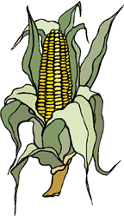 | 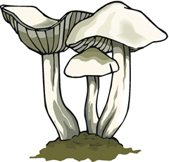

a. Pumpkins and corn grow more slowly than mushrooms.
b. Pumpkins and corn need less moisture than mushrooms.
c. Pumpkins and corn taste different than mushrooms.
d. Pumpkins and corn both make their own food.

8. Living organisms are classified into kingdoms based on their structure and shared characteristics. In what kingdom would a scientist classify an organism that is made up of eukaryotic cells, is multicellular, and is a consumer?
a. Protista
b. Archaea
c. Plantae
d. Animalia
9. Heidi Takashi is a farmer who grows corn. About 10 years ago, Ms. Takashi began spraying her fields with herbicide, a chemical that kills plants, to kill weeds in the corn field. For a few years the herbicide killed nearly all of the weeds in Ms. Takashi’s corn field. One year, Ms. Takashi noticed that some weeds were growing even after being sprayed with herbicide. The next year, even more weeds were still alive after herbicide-spraying. Based on what you know about how organisms adapt to their environment, what is the most likely reason to explain the results of Ms. Takashi’s use of herbicide?
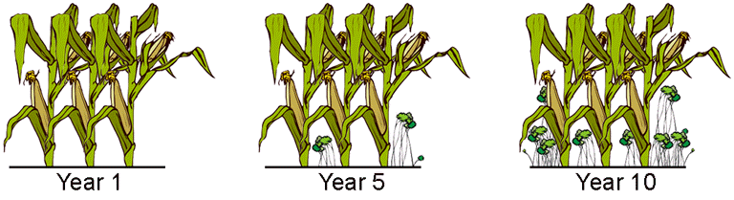

a. The weeds underwent a mutation which led to a resistance to herbicide.
b. The weeds were new species of weeds.
c. The herbicide was still effective on Ms. Takashi’s weeds.
d. The herbicide underwent a chemical change.

10. At one time, scientists believed all organisms belonged to either the plant kingdom or the animal kingdom. Today some scientists classify organisms into one of six kingdoms: plant, animal, fungus, protist, eubacteria, and archaebacteria. Which of these characteristics helps determine the kingdom to which an organism belongs?

Kingdoms of Living Things
Kingdom | Number of Cells
Archaebacteria | Single-celled
Eubacteria | Single-celled
Protista | Single-celled and multi-celled
Plantae | Single-celled and multi-celled
Fungi | Multi-celled
Animalia | Multi-celled
a. where the organism lives
b. the size of the organism
c. whether the organism can photosynthesize
d. whether the organism has a cell membrane

11. Which kind of evidence led scientists to suspect that species may change over time?
a. fossils of marine organisms that were found buried in the sides of mountains
b. a recent theory stating that new organisms can only come from older organisms
c. experiments in which plants were crossbred to produce offspring with traits from each parent
d. sequential layers of fossils that have the remains of the most modern-looking organisms in the top layers

12. What is a dichotomous key?
a. A tool that allows a scientist to categorize organisms that only have two legs
b. A tool use to identify species by giving a series of choices that lead to the name
c. A chart that helps classify organisms using DNA samples and electrophoresis
d. A chart with pictures of organisms that help to categorize them by height and width

13. Durio grandiflorus is a plant species that produces edible fruits. Which of these species MOST likely produces similar fruits?
a. Rosa gallica
b. Durio dulcis
c. Rosa grandiflora
d. Magnolia grandiflora

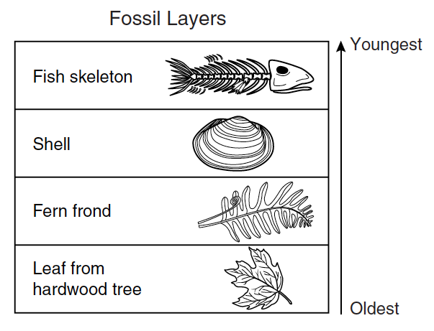
14. During a severe drought a dry lake was explored for fossils. The diagram below represents the fossils uncovered and the layers they were in.
According to this information, this area was once a—

a. forest that was replaced by a freshwater lake
b. freshwater lake that was replaced by a desert
c. saltwater sea that was replaced by a forest
d. freshwater lake that was replaced by a forest

15. Many scientists classify viruses as non-living things. Which of these best describes why a virus might be classified as non-living?
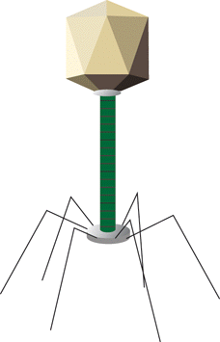

a. It has no genetic material of its own.
b. It reproduces only when it is inside a cell.
c. It can take control of a cell and change its normal activities.
d. Its effects on an organism are always harmful.

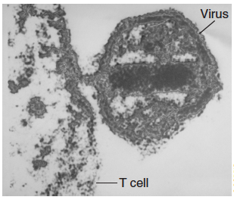

16. The photograph to the right shows a virus attacking a human T cell (immune cell).
Which disease could result if many T cells are destroyed in this manner?
a. AIDS
b. Tuberculosis
c. Chicken pox
d. Multiple sclerosis

17. A virus has been approved for use as a food additive because it attacks and kills bacteria harmful to humans. The virus kills the bacteria by doing which of the following?
a. ingesting the bacteria
b. injecting its own genetic material into the bacteria
c. absorbing the oxygen that the bacteria need for respiration
d. producing toxins that prevent the bacteria from reproducing

18. Viruses that contain RNA as their genetic information are
a. prophages
b. bacteriophages
d. retroviruses
d. capsids

19. If a flu virus infects a person, which of the following will MOST likely occur inside the person?
a. Deformed bone and skin cells will appear
b. The pH of the bloodstream will change slightly
c. The number of viruses will increase dramatically
d. Body cells will temporarily stop undergoing mitosis

20. How does a virus differ from a cell?
a. Viruses are much larger than the largest cells
b. A virus cannot copy itself unless it is inside a living cell
c. Cells make people sick, but viruses heal them
d. A virus can make copies of itself before invading a body

21. How does using killed or weakened bacteria in an immunization help the body prevent infections?
a. Antibodies are formed that fight those types of bacteria
b. The body develops a fever that kills beneficial bacteria
c. Bacterial reproductive cycles are disrupted
d. Bacteria-fighting viruses are activated

22. What is the basic structure of a virus?
a. DNA or RNA surrounded by a protein coat
b. a capsid surrounded by a protein coat
c. a tail sheath surrounded by tail fibers
d. a tiny cell surrounded by a cell wall

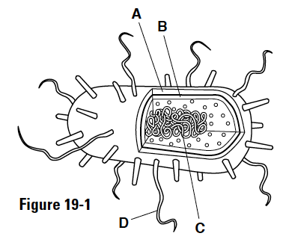

Refer to the figure to the right to answers 23 and 24.

23. The structure labeled C in the figure above is—
a. DNA
b. an organelle
c. the nucleus
d. a high-energy sugar

24. The structure labeled D in the figure above is—
a. DNA

b. pilus
c. flagella
d. cilia

25. Some antibiotics cause patients to exhibit digestive side effects. These side effects are most often the result of—
a. bacteria being killed in the digestive tract
b. the antibiotics being converted into stomach acids
c. too much water being drawn into the digestive tract
d. the stomach wall being torn

