DNA, Pedigrees, and Ecology Name _________________________
March 22, 2017
- Carbon flows cyclically through organisms and the environment. Which of the following descriptions of the carbon cycle is NOT correct?
A Major reservoirs of carbon include tropical forests, oceans and fossil fuels.
B Carbon is produced through photosynthesis and used in cellular respiration.
C Humans may disrupt the carbon cycle by burning fossil fuels which may result in global warming.
D Carbon is released to the atmosphere in the form of CO₂ through respiration in living things.
Use the diagram for the question 2-4.
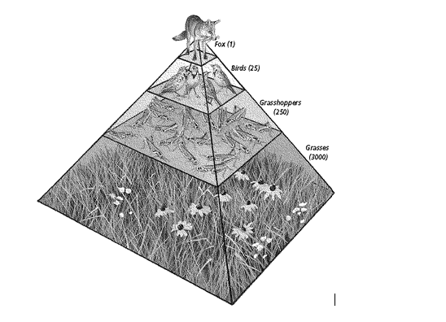
- What is the best explanation of why the numbers of organisms at each trophic level decrease from the bottom of the pyramid to the top?

A The organisms increase in size as you move up the pyramid.
B Energy is used for life processes and lost as heat at each trophic level.
C Energy is wasted and destroyed at each trophic level.
D There is more sunlight available to the first trophic level

- Which trophic level would grasshoppers be classified?
- Primary Producers
- Primary Carnivores
- Primary Consumers
- Secondary Consumers

- If grasshoppers migrated to another location, what do you think is the most likely consequence to this trophic cascade?
- The bird population would increase
- The fox population would start feeding on grasses due to a new niche being created due to the void of grasshoppers
- The grasses and cone head flowers population would increase
- The bird population would start feeding on grass due to a new niche being created by the void of grasshoppers

- DNA would best be classified as a
- Carbohydrate C. Protein
- Lipid D. Nucleic Acid

Look at the pedigrees below and predict the mode of inheritance for each.
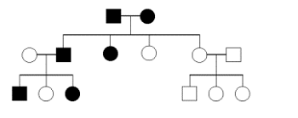

- Autosomal Dominant
- Sex-linked Dominant
- Autosomal Recessive
- Sex-linked Recessive

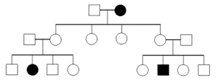
- Autosomal Dominant
- Sex-linked Dominant
- Autosomal Recessive
- Sex-linked Recessive

- A segment of DNA strand has the following bases:
TAC GAT CAT ATA
What is the complementary strand of DNA?

- UAG CAU GAU AUA
- TAG CAT GAT ATA
- ATG CTA GTA TAT
- AUG CUA GUA UAU

- Which of the following bases below would NOT be found in DNA
- Adenine C. Uracil
- Guanine D. Thymine

