SURFIN’ THROUGH STAAR
Session 3: Genetics & Heredity
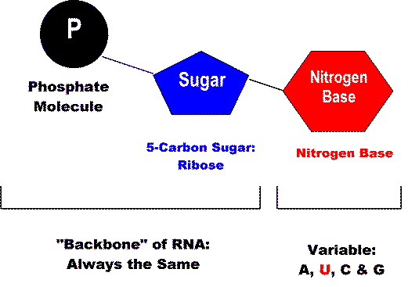
Background Information (Sessions 3 & 4 Info):
DNA- deoxyribonucleic acid- large, complex macromolecule (polymer) makes up our chromosomes, located in nucleus of the cell, controls all activities of cell, double helix structure

Nucleotides- monomers (building blocks) that connect together to make up the polymer DNA
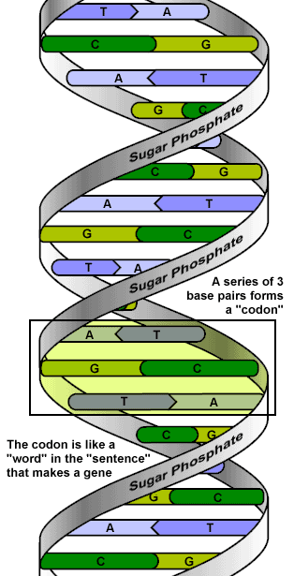
3 Parts: sugar (deoxyribose is sugar for DNA, ribose is sugar for RNA), phosphate group, & one of 4 nitrogenous bases (DNA- adenine, thymine, guanine, cystosine & uracil replaces thymine in RNA)

Bonds: The strong, covalent bonds between the sugar-phosphate-sugar backbone of DNA are called phosphodiester bonds. They hold the nucleotides together.
The “steps or rungs” of the twisted ladder of DNA are made up of two nitrogen bases that are connected in the middle by weak hydrogen bonds.

Complementary base pairs:
Adenine and thymine always pair up to form a step/rung. They are held by a double hydrogen bond.
Cytosine and guanine always pair to form a step/rung. They are held by a triple hydrogen bond.
Purines- adenine (A) and guanine (G)- larger size
Pyrimidines- cytosine (C) and thymine (T)- smaller size
A trick to remember which bases pair together is to remember that the letters made with straight lines go together (A & T) and the letters made with curved lines go together (C & G).
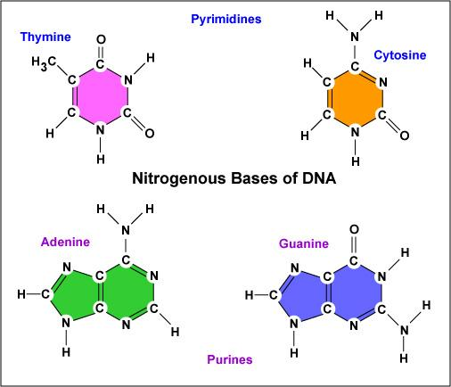
DNA Antiparallel Structure:
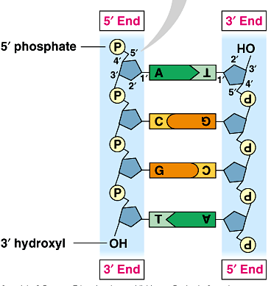
-Most DNA is twisted/coiled to the right
-one strand is the 3’ (3 prime)= the side with the free OH group on the end
-one strand is the 5’ (5 prime)= the side with the free phosphate on the end

DNA Replication:
The process by which a strand of DNA is copied occurs during something called replication.
In order to do this, the enzyme DNA helicase moves down a molecule of DNA and breaks the weak hydrogen bonds between the nitrogen bases (A,T, C and G).
When they do this they “unzip” the ladder, which comes apart and the two sides of the ladder separate.
A different enzyme, DNA polymerase comes along afterward and links the sugar and phosphate molecules back up again, making new nucleotides and creating a new ladder side for each of the old strands that came apart.
Each new strand of DNA now has half of the old strand that came apart and half of a new strand that was just created.
At the end of replication, there are 2 new identical strands of DNA- 1 side is from the original DNA strand (template)- The other side is the newly formed strand that was “copied”
Replication is the process in which a DNA model is copied and that replication occurs during the S (synthesis) phase of Interphase right before mitosis.
DNA, Proteins & Genetic Coding: DNA is directly connected to proteins because it contains the “master plan” for all living organisms.
Proteins are made up of smaller units (monomers) called amino acids, which are linked together in a specific order to make specific proteins.
These nitrogen bases link together in three’s to form a codon and many codons link together to form a person’s genetic code.
Codons, DNA triplets, code for one amino acid.
Amino acids link together to form polypeptides-chain containing 2 or more amino acids
Polypeptides make up proteins.
Genes code for polypeptides. Gene- a specific sequence of nucleotides forming part of a chromosome that codes for a trait (protein)
Codons are made up of 3 nitrogen bases, so they look like this: base + base + base = codon (Ex. ACG = a codon)
When you read one codon at a time it can be used to determine which amino acid (and this determines which protein) each strand of DNA or RNA will code for.

Transcription: Changing DNA to RNA:
It is important to realize that DNA and proteins have a direct relationship.
In other words, DNA is used to make proteins and the first step by which it does this is a process called transcription.
RNA Bases:
The nitrogen bases are named as follows: adenine (A), uracil (U), cytosine (C), and guanine (G).
Notice- RNA does not contain the base thymine (T), instead adenine (A) will pair with uracil (U).
In transcription, an RNA (ribonucleic acid) strand is made from a strand of DNA.
In order for this to occur, a DNA strand unzips and RNA bases come along and pair up with the exposed DNA bases.
Enzymes reassemble the nucleotides and the strand is now called mRNA, or messenger RNA.
This is called messenger RNA because it will now deliver a message telling the ribosomes in the cell to get ready to start making proteins.
Recall… what is the function of a ribosome? Synthesize proteins
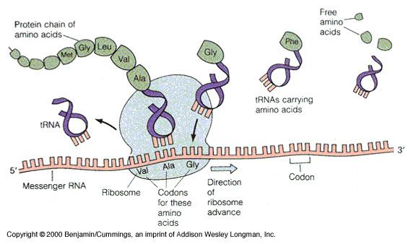
Differences in DNA & RNA:
DNA
Double strand
Deoxyribose sugar
Thymine
In DNA, thymine pairs with adenine.
RNA
Single strand
Ribose sugar
Uracil instead of Thymine
In RNA, uracil pairs with adenine.

Translation: Converting RNA to Proteins
Translation is the process by which proteins are made using RNA.
This process occurs in the ribosomes of the cell.
Translation happens when the ribosome reads the mRNA code and translates it into a specific amino acid sequence, which becomes a protein.
Amino acids continue to link together to form proteins inside the ribosomes until a “stop” codon is read and the finished proteins are released into the cell.
transcription translation
DNA RNA Protein
Genetics: The scientific study of heredity is called genetics. Heredity is the study of how traits are passed from parent to offspring.
A genotype is what we call the genetic make-up of organism.
A person’s phenotype is a physical description of their genotype.
For example: A genotype that reads BB for hair color probably means that a person’s phenotype for hair color is black
An individual that has two different alleles for the same trait is said to be heterozygous (Bb).
An individual that has two identical alleles for one trait is said to be homozygous (bb or BB).

Mendel:
A scientist named Gregor Mendel used purebred pea plants in order to understand how traits are inherited. In his experiments, Mendel discovered that each trait is controlled by one gene that occurs in two different forms. These different forms are referred to as alleles.

Mendel’s Theories:
Theory of Dominance: Mendel concluded that some alleles are dominant & some are recessive.When an organism inherits a dominant allele that trait is visible and the effects of a recessive allele cannot be seen. Example: Brown eyes are usually dominant over blue eyes.
This doesn’t mean that a recessive allele just disappears only that it is masked by the dominant one, making it invisible.
Theory of Segregation: Mendel concluded that alleles separate when sex cells (egg & sperm) are formed. Each sex cell carries only one copy of each gene.
Law of Independent Assortment: Mendel found that genes that control one trait (like hair color) do not affect genes that control another trait (like hair texture). Each gene sorts independent of all others during the formation of sex cells.
Some alleles are neither dominant nor recessive, and many traits are controlled by multiple alleles or multiple genes. Here are some exceptions to Mendel’s principles:
Incomplete dominance: Occurs when one allele is not completely dominant over another. For example, a cross between a red-flowered plant and a white-flowered plant that results in pink-flowered offspring.
Codominance: Occurs when both alleles contribute to a one’s physical characteristics (phenotype). For example, in some species of chicken black feathers and white feathers are codominant, therefore chickens that have these genes display speckled black and white feathers

Monohybrid Crosses
- A cross that provides data about one set of traits. (mono = one, hybrid = cross)
- Each box is filled with two letters: one from the left side of the square and one from the top of the square; note that the dominant trait is always written first.
- The letters indicate the possible genotypes of the offspring.
  - For example: A cross between homozygous dominant (TT) and homozygous recessive (tt) plant:

 | T | T
t | Tt | Tt
t | Tt | Tt

 | T | t
T | TT | Tt
t | Tt | tt

For example: A cross between two heterozygous plants (Tt x Tt).

Dihybrid Crosses
- A cross that involves two pairs of contrasting traits
(di = two, hybrid = cross).
- In these crosses, alleles must be independently sorted and then listed for the cross.
- For example: A cross between two heterozygous guinea pigs (SsBb x SsBb):
 | SB | Sb | sB | sb
SB | SSBB | SSBb | SsBB | SbBb
Sb | SSBb | SSbb | SbBb | Ssbb
sB | SsBB | Ssbb | ssBB | ssBb
sb | SSBb | SSbb | ssBb | Ssbb
The offspring that result from the cross of these two heterozygous guinea pigs have four different phenotypes:
9/16 = short, black hair | 3/16 = short, black hair
3/16 = long, black hair | 1/16 = long, brown hair

Specific biomolecules serve various functions in the body.

1. Study the statement above. Identify the molecule which contains the instructions used to create an organism’s enzymes and proteins.
a. nicotinamide adenine dinucleotide (NAD+)
b. hemoglobin
c. deoxyribonucleic acid (DNA)
d. glucose

2. RNA molecules use instruction from DNA to assemble proteins. There are three types of RNA molecules: mRNA, rRNA and tRNA. What specific function does mRNA perform in the process of making proteins?
a. It brings instructions from DNA in the cell nucleus to the cytoplasm.
b. It clamps onto messenger RNA and uses its information to assemble amino acids.
c. It transports amino acids to the ribosomes to be assembled into proteins.
d. It creates another molecule of DNA through replication.

3. Which of the following correctly shows a complementary base pair of nitrogenous bases in a DNA molecule?
a. adenine- guanine
b. guanine- cytosine
c. cytosine- adenine
d. guanine- thymine
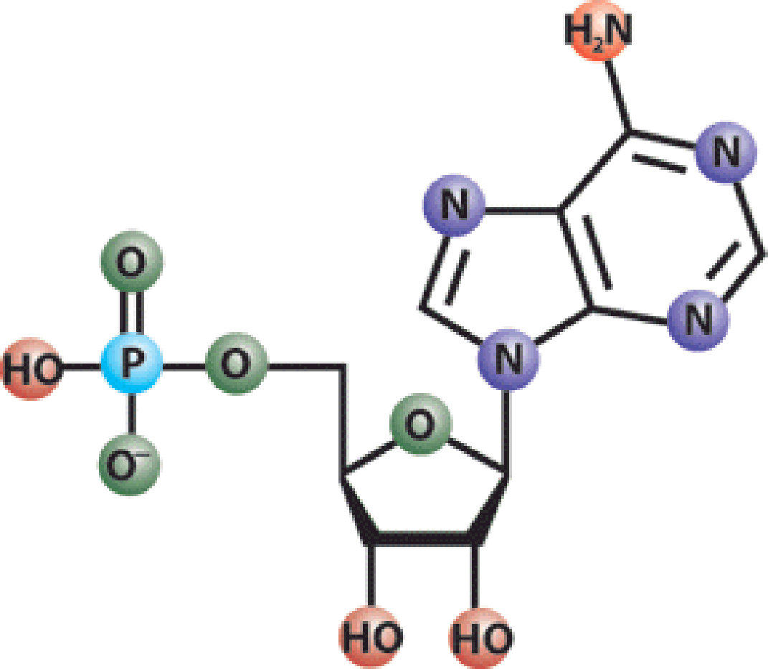
4. DNA is a polymer which is made up of subunits called nucleotides. Nucleotides have three basic parts. Which of these is not a nucleotide component?

a. deoxyribose sugar
b. phosphate group
c. ribose sugar
d. nitrogenous base

5. A nitrogenous base is an important component of the nucleotide making up DNA. Which of the following correctly lists the four possible nitrogenous bases in DNA?
a. adenine, guanine, cytosine, uracil
b. leucine, proline, tyrosine, phenylalanine
c. glutamine, proline, tyrosine, phenylalanine
d. adenine, guanine, cytosine, thymine

6. Translation is crucial to the process of making proteins. Which statement best describes what takes place during translation?
a. An RNA copy of a DNA strand is made.
b. Information in mRNA is converted into a sequence of amino acids in a protein.
c. A copy of chromosomal DNA is created.
d. Instructions from DNA in the nucleus are brought to the cytoplasm.

7. In order for DNA instructions to move from the nucleus to the ribosomes in the cytoplasm of a cell, an RNA copy of a DNA strand must be made. This process, which takes place in the cell nucleus, is called-
a. translation b. DNA replication c. mutation d. transcription

8. John has one recessive allele for blue eyes (b) and one dominant allele for brown eyes (B). Amy also has one recessive allele for blue eyes and one dominant allele for brown eyes. What phenotype is an offspring of John and Amy most likely to express?
a. Bb b. BB c. blue eyes d. brown eyes

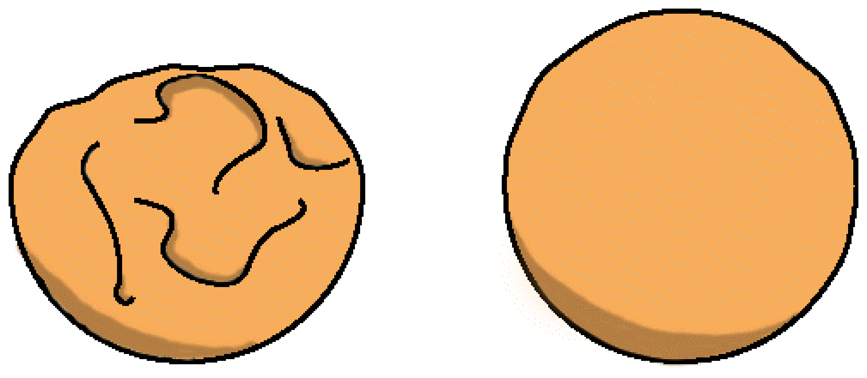
Gregor Johann Mendel was an Austrian monk who is considered to be the father of genetics. In the 1850’s Mendel began doing experiments on pea plants. In one experiment Mendel took one pea plant with smooth seeds and crossed it with another pea plant with wrinkled seeds. Then he looked at the offspring from this cross. He found that all of the offspring produced only smooth seeds. In his experiments, Mendel was careful to use only pure-breeding strains of peas.

Wrinkled Smooth

9. Refer to the information above. Which statement is true about pure strains?
a. Pure-breeding strains arise from self-pollination.
b. Pure-breeding strains do not produce pollen.
c. Pure-breeding strains produce seed faster than non-pure plants.
d. Pure-breeding strains are easier to cross-pollinate.

10. Refer to the information above. Which statement is true about pure strains?
a. Pure-breeding strains grow more quickly than regular plants.
b. Pure-breeding strains have traits that skip generations.
c. Pure-breeding strains allowed Mendel to uncover the law of genetics.
d. Pure-breeding strains are hybrids.

11. Refer to the information above. Why did the offspring of Mendel’s cross all have smooth seeds?
a. The wrinkled trait showed incomplete dominance.
b. The smooth trait was dominant.
c. The wrinkled trait was lost by spontaneous mutation.
d. The offspring did not contain the gene for the wrinkled trait.

12. Refer to the description above. After doing the initial cross with smooth and wrinkled peas, Mendel then took the offspring (all smooth) and crossed them with each other. If Mendel looked at 1000 seeds in the next generation, approximately how many seeds would you expect to show each trait?
a. 500 smooth seeds, 500 wrinkled seeds
b. 750 smooth seeds, 250 wrinkled seeds
c. 1000 smooth seeds, 0 wrinkled seeds
d. 1000 wrinkled seeds, 0 smooth seeds

13. Bill grows two varieties of corn in his garden. One variety produces large ears of corn and one makes small ears of corn. When Bill crosses the two plants the resulting ears of corn are medium in size. Which statement best explains Bill’s result?
a. The corn underwent a spontaneous mutation.
b. Ear size is a trait that shows incomplete dominance.
c. Ear size is controlled by the environment.
d. Ear size is not genetically controlled.

14. What process produces many variations in phenotypes?
a. independent assortment
b. asexual reproduction
c. regeneration
d. cloning

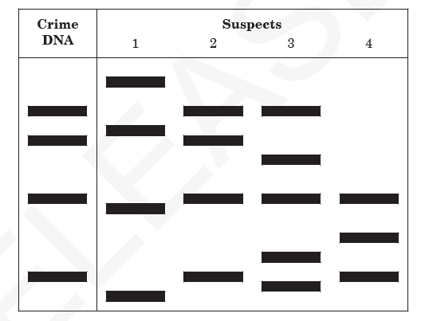
15. This diagram represents samples of DNA that were cut with a restriction enzyme during DNA fingerprinting in a crime lab.

Which technique was used to produce these bands?
a. cloning
b. gel electrophoresis
c. gene splicing
d. genetic engineering

16. This chart represents amino acids that are coded from different combinations of mRNA codons.
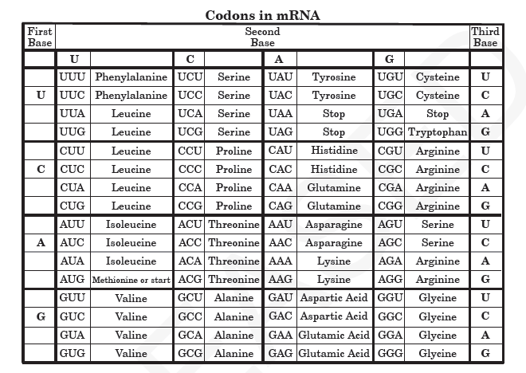

Which amino acid sequence can be coded from the DNA sequence CAG TAG CGA?
a. Valine- Isoleucine- Glycine
b. Valine- Aspartic Acid- Alanine
c. Valine- Isoleucine- Alanine
d. Valine- Phenylalanine- Alanine
(Hint: match the DNA sequence above with the following RNA sequence: GUC AUC GCU then use codon chart)

17. Refer to the Codon chart above. A strand of DNA with the sequence AAC AAG CCC undergoes a mutation, and the first A is changed to a C. How will this mutation affect the amino acid sequence?
a. One amino acid will change.
b. Two amino acids will change.
c. All of the amino acids will change.
d. The amino acids will remain the same.

18. One of the parents of a child has phenylketonuria (PKU), which is caused by recessive alleles. The other parent does not have the PKU alleles. What is the chance that the couple will have a child with phenylketonuria?
a. O% b. 50% c. 75% d. 100%
(Hint: both parents would have to be recessive for child to have PKU because it is caused by recessive alleles)

19. A scientist treats a cell with a chemical that destroys the ribosomes. As a result, which cell process will be stopped?
a. osmosis b. photosynthesis c. protein synthesis d. respiration

20. Hitchhiker’s thumb (H) is dominant to no hitchhiker’s thumb (h). A woman who does not have hitchhiker’s thumb marries a man who is heterozygous for hitchhiker’s thumb. What is the probable genotypic ratio of their children? h h
Hh | Hh
hh | hh
a. 0% Hh : 100% hh
b. 50% Hh : 50% hh H
c. 75% Hh : 25% hh
d. 100% Hh : 0% hh h

21. A sugar, a phosphate group, and a nitrogen base form the building blocks of which organic compound?
a. carbohydrates
b. lipids
c. nucleic acids
d. proteins

22. A genetic counselor is examining a karyotype from a patient when an extra copy of chromosome 13 is noticed. This condition is referred to as
a. trisomy
b. diploidy
c. triploidy
d. monosomy

SURFIN’ THROUGH STAAR
Session 4: Genetics & Heredity

Background Information (Sessions 3 & 4 Info):
DNA- deoxyribonucleic acid- large, complex macromolecule (polymer) makes up our chromosomes, located in nucleus of the cell, controls all activities of cell, double helix structure

Nucleotides- monomers (building blocks) that connect together to make up the polymer DNA
3 Parts: sugar (deoxyribose is sugar for DNA, ribose is sugar for RNA), phosphate group, & one of 4 nitrogenous bases (DNA- adenine, thymine, guanine, cystosine & uracil replaces thymine in RNA)

Bonds: The strong, covalent bonds between the sugar-phosphate-sugar backbone of DNA are called phosphodiester bonds. They hold the nucleotides together.
The “steps or rungs” of the twisted ladder of DNA are made up of two nitrogen bases that are connected in the middle by weak hydrogen bonds.

Complementary base pairs:
Adenine and thymine always pair up to form a step/rung. They are held by a double hydrogen bond.
Cytosine and guanine always pair to form a step/rung. They are held by a triple hydrogen bond.
Purines- adenine (A) and guanine (G)- larger size
Pyrimidines- cytosine (C) and thymine (T)- smaller size
A trick to remember which bases pair together is to remember that the letters made with straight lines go together (A & T) and the letters made with curved lines go together (C & G).
DNA Antiparallel Structure:
-Most DNA is twisted/coiled to the right
-one strand is the 3’ (3 prime)= the side with the free OH group on the end
-one strand is the 5’ (5 prime)= the side with the free phosphate on the end

DNA Replication:
The process by which a strand of DNA is copied occurs during something called replication.

In order to do this, the enzyme DNA helicase moves down a molecule of DNA and breaks the weak hydrogen bonds between the nitrogen bases (A,T, C and G).
When they do this they “unzip” the ladder, which comes apart and the two sides of the ladder separate.
A different enzyme, DNA polymerase comes along afterward and links the sugar and phosphate molecules back up again, making new nucleotides and creating a new ladder side for each of the old strands that came apart.
Each new strand of DNA now has half of the old strand that came apart and half of a new strand that was just created.
At the end of replication, there are 2 new identical strands of DNA- 1 side is from the original DNA strand (template)- The other side is the newly formed strand that was “copied”
Replication is the process in which a DNA model is copied and that replication occurs during the S (synthesis) phase of Interphase right before mitosis.
DNA, Proteins & Genetic Coding: DNA is directly connected to proteins because it contains the “master plan” for all living organisms.
Proteins are made up of smaller units (monomers) called amino acids, which are linked together in a specific order to make specific proteins.
These nitrogen bases link together in three’s to form a codon and many codons link together to form a person’s genetic code.
Codons, DNA triplets, code for one amino acid.
Amino acids link together to form polypeptides-chain containing 2 or more amino acids
Polypeptides make up proteins.
Genes code for polypeptides. Gene- a specific sequence of nucleotides forming part of a chromosome that codes for a trait (protein)
Codons are made up of 3 nitrogen bases, so they look like this: base + base + base = codon (Ex. ACG = a codon)
When you read one codon at a time it can be used to determine which amino acid (and this determines which protein) each strand of DNA or RNA will code for.

Transcription: Changing DNA to RNA:
It is important to realize that DNA and proteins have a direct relationship.
In other words, DNA is used to make proteins and the first step by which it does this is a process called transcription.
RNA Bases:
The nitrogen bases are named as follows: adenine (A), uracil (U), cytosine (C), and guanine (G).
Notice- RNA does not contain the base thymine (T), instead adenine (A) will pair with uracil (U).
In transcription, an RNA (ribonucleic acid) strand is made from a strand of DNA.
In order for this to occur, a DNA strand unzips and RNA bases come along and pair up with the exposed DNA bases.
Enzymes reassemble the nucleotides and the strand is now called mRNA, or messenger RNA.
This is called messenger RNA because it will now deliver a message telling the ribosomes in the cell to get ready to start making proteins.
Recall… what is the function of a ribosome? Synthesize proteins
Differences in DNA & RNA:
DNA
Double strand
Deoxyribose sugar
Thymine
In DNA, thymine pairs with adenine.
RNA
Single strand
Ribose sugar
Uracil instead of Thymine
In RNA, uracil pairs with adenine.

Translation: Converting RNA to Proteins
Translation is the process by which proteins are made using RNA.
This process occurs in the ribosomes of the cell.
Translation happens when the ribosome reads the mRNA code and translates it into a specific amino acid sequence, which becomes a protein.
Amino acids continue to link together to form proteins inside the ribosomes until a “stop” codon is read and the finished proteins are released into the cell.
transcription translation
DNA RNA Protein
Genetics: The scientific study of heredity is called genetics. Heredity is the study of how traits are passed from parent to offspring.
A genotype is what we call the genetic make-up of organism.
A person’s phenotype is a physical description of their genotype.
For example: A genotype that reads BB for hair color probably means that a person’s phenotype for hair color is black
An individual that has two different alleles for the same trait is said to be heterozygous (Bb).
An individual that has two identical alleles for one trait is said to be homozygous (bb or BB).

Mendel:
A scientist named Gregor Mendel used purebred pea plants in order to understand how traits are inherited. In his experiments, Mendel discovered that each trait is controlled by one gene that occurs in two different forms. These different forms are referred to as alleles.

Mendel’s Theories:
Theory of Dominance: Mendel concluded that some alleles are dominant & some are recessive.When an organism inherits a dominant allele that trait is visible and the effects of a recessive allele cannot be seen. Example: Brown eyes are usually dominant over blue eyes.
This doesn’t mean that a recessive allele just disappears only that it is masked by the dominant one, making it invisible.
Theory of Segregation: Mendel concluded that alleles separate when sex cells (egg & sperm) are formed. Each sex cell carries only one copy of each gene.
Law of Independent Assortment: Mendel found that genes that control one trait (like hair color) do not affect genes that control another trait (like hair texture). Each gene sorts independent of all others during the formation of sex cells.
Some alleles are neither dominant nor recessive, and many traits are controlled by multiple alleles or multiple genes. Here are some exceptions to Mendel’s principles:
Incomplete dominance: Occurs when one allele is not completely dominant over another. For example, a cross between a red-flowered plant and a white-flowered plant that results in pink-flowered offspring.
Codominance: Occurs when both alleles contribute to a one’s physical characteristics (phenotype). For example, in some species of chicken black feathers and white feathers are codominant, therefore chickens that have these genes display speckled black and white feathers

Monohybrid Crosses
- A cross that provides data about one set of traits. (mono = one, hybrid = cross)
- Each box is filled with two letters: one from the left side of the square and one from the top of the square; note that the dominant trait is always written first.
- The letters indicate the possible genotypes of the offspring.
  - For example: A cross between homozygous dominant (TT) and homozygous recessive (tt) plant:

 | T | T
t | Tt | Tt
t | Tt | Tt

 | T | t
T | TT | Tt
t | Tt | tt

For example: A cross between two heterozygous plants (Tt x Tt).

Dihybrid Crosses
- A cross that involves two pairs of contrasting traits
(di = two, hybrid = cross).
- In these crosses, alleles must be independently sorted and then listed for the cross.
- For example: A cross between two heterozygous guinea pigs (SsBb x SsBb):
 | SB | Sb | sB | sb
SB | SSBB | SSBb | SsBB | SbBb
Sb | SSBb | SSbb | SbBb | Ssbb
sB | SsBB | Ssbb | ssBB | ssBb
sb | SSBb | SSbb | ssBb | Ssbb
The offspring that result from the cross of these two heterozygous guinea pigs have four different phenotypes:
9/16 = short, black hair | 3/16 = short, black hair
3/16 = long, black hair | 1/16 = long, brown hair

1. This chart shows the results of several crosses with white-feathered chickens and dark-feathered chickens.

Cross | Parental Feather Colors | Offspring Feather Colors
1 | White x White | 100% White
2 | White x White | 75% White, 25% Dark
3 | White x Dark | 50% White, 50% Dark
4 | Dark x Dark | 100% Dark

Which cross would be represented as Aa x aa, where (A) represents a dominant allele and (a) represents a recessive allele?
a. Cross 1 b. Cross 2 c. Cross 3 d. Cross 4
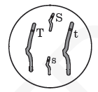
2. This diagram shows a diploid cell with two pairs of homologous chromosomes.

Due to independent assortment, what is the possible genetic make-up of gametes produced by this organism?
a. SsTt
b. SS, Tt
c. S, s, T, t
d. ST, St, sT, st

3. Which genetic abnormality can be identified through karyotyping?
a. point mutation b. recessive allele c. extra chromosome d. sex-linked allele

4. During DNA replication, which of the following segments would be complementary to the original DNA segment of CCTAAT?
a. CGATTA
b. GGUTTU
c. GGATTA
d. GGAUUA

5. What type of RNA is responsible for bringing amino acids to the ribosome for protein synthesis?
a. messenger RNA
b. transfer RNA
c. ribosomal RNA
d. mitochondrial RNA

6. To determine the molecular sequence of a gene for a protein, which molecule should be analyzed?
a. tRNA b. ATP c. DNA d. rRNA

7. If a portion of a DNA strand has the base sequence TACGCA, what will be the base sequence of the mRNA strand transcribed?
a. TACGCA b. UACGCA c. AUGCGU d. ATGCGT

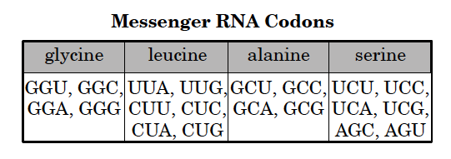
8. The chart to the right matches messenger RNA
codons with amino acids.

A DNA strand has the codon TCA. According to the chart, the corresponding messenger RNA codes for which of the following amino acids?
a. glycine
b. leucine
c. alanine
d. serine

9. In a genetics laboratory, two heterozygous tall plants are crossed. If tall is dominant over short, what are the expected phenotypic results? T t
TT | Tt
Tt | tt
a. 100% tall
b. 75% tall, 25% short T TT, Tt, Tt- tall tt- short
c. 50% tall, 50% short
d. 25% tall, 75% short t

10. When viewing a karyotype to detect genetic disorders, which of the following would be a concern?
a. different chromosomes of different lengths
b. two X chromosomes
c. twenty-three pairs of chromosomes
d. three chromosomes in any one set
11. Color blindness is a sex-linked recessive trait. A mother with normal color vision and a color blind father have a color blind daughter. Which of the following statements is correct? X^{b} Y
X^{B}X^{b} | X^{B}Y
X^{b}X^{b} | X^{b}Y
a. All of their daughters will be color blind.
b. The mother is a carrier of the color blindness gene. X^{B}
c. All of their sons will have normal color vision.
d. All of their sons will be color blind. X^{b}

(Hint: Daughter is color blind so she must be X^{b}X^{b} as color blindness is a sex-linked recessive trait. That means she gets one X from mom and one from dad. Dad is color blind so his only X is X^{b}- all he can pass on to his daughters is the infected X with color blindness. If daughter is X^{b}X^{b} as she is color blind, one infected X came from dad, other must have come from mom. Mom has normal vision so she can’t be X^{b}X^{b} , therefore she is heter X^{B}X^{b.}.)

12. After performing amniocentesis, which analysis is most often used to determine the chromosomal condition of a developing fetus?
a. blood type
b. DNA sequence
c. genetic marker
d. karyotype

13. Albinism is a genetic mutation that results in some animals being born without the enzyme that produces the pigment for skin and eye color. Which of the following best explains this mutation?
a. The DNA failed to replicate.
b. The deoxyribose sugar became separated from the DNA.
c. The genetic code change caused the wrong protein to form.
d. The RNA necessary to produce proteins was not present.

14. This diagram shows a pedigree for a recessive genetic disorder.
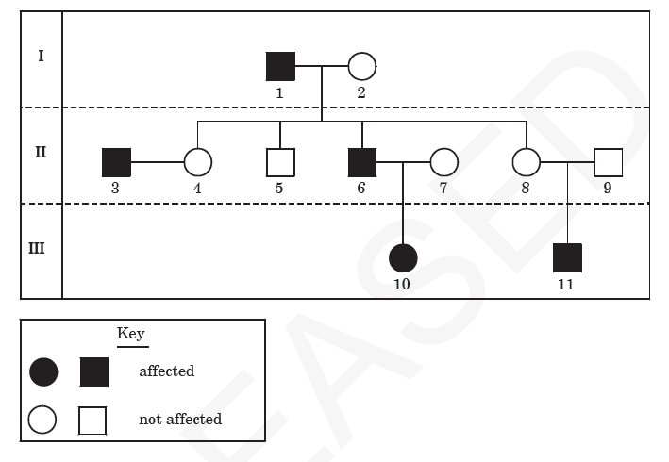

What is the genotype of individual 6?
a. X^{H}X^{H} b. X^{H}X^{h} c. X^{H}Y d. X^{h}Y

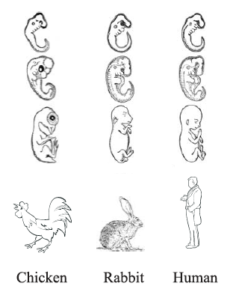
15. The figure to the right shows embryonic stages of three different kinds of organisms.

What does the figure suggest about these organisms?
a. They underwent similar mutations.
b. The share the same acquired traits.
c. They originated in the same location.
d. They show similar embryonic development.

16. How do the functions of DNA and RNA differ?
a. DNA directs protein transport, while RNA aids in energy production.
b. DNA aids in energy production, while RNA directs protein transport.
c. DNA stores genetic information, while RNA relays genetic information for protein synthesis.
d. DNA relays genetic information for protein synthesis, while RNA stores genetic information.

17. One way in which a point mutation and a deletion mutation are different is that
a. a point mutation is always harmful, and a deletion mutation is never harmful
b. a point mutation is a physical change, and a deletion mutation is a chemical change
c. a point mutation always results in a frameshift mutation, while a deletion mutation never results in a frameshift mutation
d. a point mutation only results in a change in a single nucleotide base, while a deletion mutation can result in a c change in multiple nucleotide bases
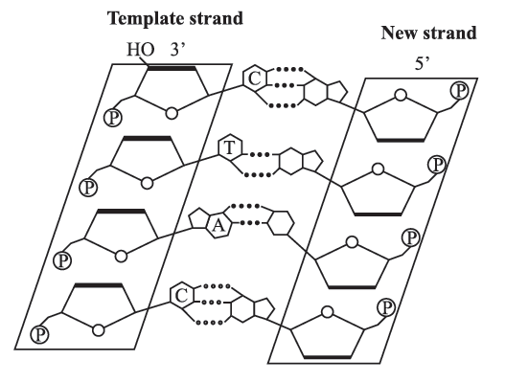
18. The illustration below shows a step in DNA replication.

Starting at the top, which list shows the identity of the bases of the new strand?
a. A, G, T, A
b. G, A, T, G
c. G, A, U, G
d. A, G, U, A

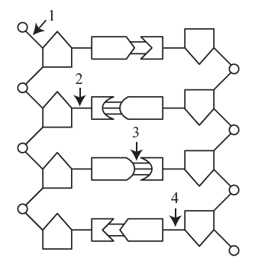
19. The graphic below represents a segment of DNA.

Which bond must be broken if DNA replication is to occur?
a. 1
b. 2
c. 3
d. 4

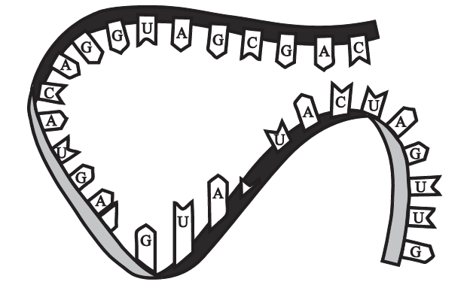
20. The figure to the right shows genetic material.

What information confirms that this is an RNA molecule?
a. The molecule contains adenine.
b. The molecule is single-stranded.
c. The molecule has hydrogen bonds.
d. The molecule has a sugar-phosphate backbone.

21. The figure to the right shows an RNA molecule found within the cell.
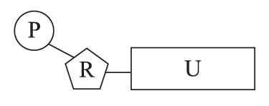
What does the letter U represent in this nucleotide?
a. ribose sugar
b. nitrogen base
c. phosphate group
d. deoxyribose sugar

22. What is the role of hydrogen bonds in the structure of DNA?
a. to code for proteins
b. to synthesize proteins
c. to separate the strands
d. to connect the base pairs

