Evolution Quiz Questions Name: __________________
Date: ___________________
- The example of the peppered moths living near English industrial cities during the Industrial Revolution demonstrates that…
- A change in an environment can result in the evolution of species living there
- Evolution occurs so slowly that it is not possible to determine that it has happened in less than a million years
- The environment near these cities has always favored dark colored moths
- None of these
- Which of the following statements is true about Charles Darwin?
- He believed that evolution was due to acquired inherited characteristics
- He hypothesizes that natural selection was a primary mechanism driving evolution
- He supported Lamarck’s explanation of evolution
- He thought that variations within organisms were imperfections
- A population consists of members of …
- Various species living in the same area
- The same species living in the same area
- The same species living in different areas
- Various species living in different areas
- How can a population benefit from biodiversity?
- It is more likely to survive if the climate changes
- Predators will leave it alone because it is so many of them
- The carrying capacity for that organism will be larger
- It will need less water
- Differential reproductive success most directly affects what mechanism of evolution
- Natural Selection
- Genetic Variation
- Competition
- Descent with modification
- The ability of a particular genotype is at leaving/creating offspring is best defined as
- Natural Selection
- Fitness
- Competition
- Monohybrid Crosses
- What is an adaptation of an animal that lives high on a mountain?
- Being active at night
- Resistance to poisonous snakes
- Large number of red blood cells
- Blubber
- From the earliest to most recent, which is the correct order of evolution?
- Prokaryotes: Photosynthetic Eukaryotes: Carnivorous Eukaryotes; Herbivorous Eukaryotes
- Photosynthetic Eukaryotes; Prokaryotes; Herbivorous Eukaryotes; Carnivorous Eukaryotes
- Prokaryotes; Photosynthetic Eukaryotes; Herbivorous Eukaryotes; Carnivorous Eukaryotes
- Photosynthetic Eukaryotes; Herbivorous Eukaryotes; Carnivorous Eukaryotes; Prokaryotes

- How does variation occur in a population?
- Mitosis E. Both A and B
- Genetic Mutations F. Both B and C
- Crossing Over G. Both B and D
- Glycolysis H. None of these
- Evolution is best defined as…
- Change in alleles in a population over time
- Change in alleles in an individual over time
- Change over time
- Changes from one species to another
- Organisms that are least likely to experience extinction over the long term are most likely to be found in …
- Areas inhabited by humans
- Very stable habitats
- Desert
- Savanna
- Classification of different organisms is listed below. According to this table which organism is most closely related to the house cat?
Classification | Examples
Kingdom- Animal | Dolphin, house cat, songbird, lynx, wolf, earthworm, beetle
Phylum- Chordata | Dolphin, house cat, songbird, lynx, wolf
Genus- Felis | House cat, Lynx
Species- domesitca | House cat

- Dolphin
- Songbird
- Lynx
- Wolf

Complete the passage using ALL the words banks below.
Population | Environment | Competition | H.M.S. Beagle
Fitness | Adaptive | Extinction | Descent with Modification
Natural Selection | Differential Reproduction Success | niche | Genetic Variation
large | small

Darwin’s trip on the 13._______________________ took him around the world in five years and was instrumental in providing Darwin with his evidence for two primary mechanism of evolution. 14_______________________________ was Darwin’s original hypothesis that all of life originated from a single common ancestor. 15_____________________________ was thought to provide the raw materials for evolution in large part thanks to 16___________________________________. Differential reproductive success is the idea that all organisms have a desire to mate, but cannot in large part due to 17___________________, 18____________________, and 19_________________________. The 20_______________________ of various finches found in the Galapagos Islands are often the premiere example of showcasing Darwin’s theory of evolution. Darwin notated how each finch were very similar to the finches of the mainland in South America, but each finch was well 21___________________ and survived by fulfilling a unique 22____________ despite living in a common 23________________________ off small islands of the coast of South America. Darwin noted that each finch feed on seeds and that 24_______________ seeds were eaten by finches with smaller and more finesse beaks; while the larger, harder seeds were eaten by finches with 25__________________ beaks.

- Oak trees are native to temperate climates and have broad leaves. Cacti are native to desert ecosystems and have modified leaves call spines. (2pts: SPI 5.1)
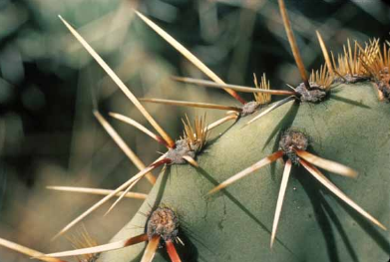
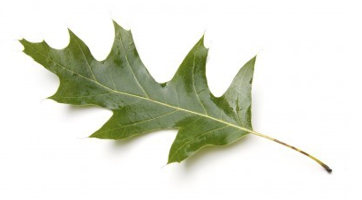

Cacti Spines Oak Tree Leaf
How are the spines on a cactus different from the leaves on an oak trees?
- They reduce water loss
- The reduce oxygen release
- They provide heat exchange
- They provide nutrient intake

- The fact that at least one species of resistant bacteria has developed for almost every antibiotic is evidence for which condition? (SPI 5.3)
- The bacteria have adapted and could be evolving into a different species
- The bacteria have learned to mimic other species
- There is no variation in the bacteria population.
- The antibiotics are being made differently.

- Binomial nomenclature is the basis of giving every organism how many names?
- 1
- 2
- 3
- 4

- The scientific name for the African elephant is Loxodonta africana. What is the species name? (SPI 5.6)
- Loxodonta
- africana
- L. africana
- Loxodonta sp.
- Charles Darwin’s two major mechanism for evolution is… (SPI 5.3)
- Survival of fittest & Competition
- Descent with Modification & Competition
- Natural Selection & Descent with Modification
- Competition & Natural Selection

- How is a theory in science different from a theory used in normal everyday language? (2pts; SPI Inq 1)

- According to the theory of natural selection, why are some individuals more likely than others to survive and reproduce? (SPI 5.4)
- They pass on to their offspring new characteristics they acquired during their lifetimes.
- They are better adapted to exist in their environment than others.
- They do not pass on to their offspring new characteristics they have acquired during their lifetimes.
- They tend to produce fewer offspring than do others in the same environment

- During the Industrial Revolution, England began burning fossil fuels such as coal as means of making energy. However, this method of energy came a cost of releasing lots of carbon dioxide into the air. What could be the long term implications of burning fossil fuels be on the environment when no filters or scrubbers were used to clean the emissions before releasing them into the atmosphere? (SPI 2.4)
- Acid Rain
- Global Warming
- Decrease forest
- All the above

- During the Industrial Revolution, England began burning fossil fuels such as coal as means of making energy. However, this method of energy came a cost of releasing lots of dirt and soot into the air and covering everything within a 10 mile radius progressively filthier. What would you predict would happen to the color of the Peppered Moth population as it got closer to the city? (SPI 2.4 &5.3)

- A darker color would become more prevalent to aid in camouflage
- A lighter color would become more prevalent to aid in camouflage
- No change, burning fossils fuels have nothing to do with wing color

- What factor within a species increases the likelihood that some members of a species will survive when environmental conditions change? (SPI 5.4)
- Variation B. Disjunction C. Polyploidy D. Migration
- What can the fossil record tell us about Earth’s history?
- Dinosaurs existed and could still be living amongst us
- Life on Earth has never changed
- The oldest fossils are found closer to the surface
- Life on Earth has changed

- Which of the following statements is true about Charles Darwin’s observations of the Galapagos Islands finches?
- He saw variation between finches of all the islands and concluded that each finch was the same species and that variation caused each finch to look differently
- He saw that each island had its own unique finch species that was adapted to eating seeds on the island
- He saw variation within tortoises on each island
- He saw variations within finches as imperfections
- Which of the following best illustrates natural selection?
- An organism with favorable genetic variations will tend to survive and breed successfully
- A population monopolizes all of the resources in its habitat, forcing other species to migrate
- A community whose members work together utilizing all existing resources and migratory routes.
- The largest organisms in a species receive the only breeding opportunities.
- Mutation within a DNA sequence are:
- natural processes that produce genetic diversity
- natural processes that never affect the way an organism looks (aka phenotype)
- unnatural processes that always affect the phenotype
- unnatural processes that are harmful to genetic diversity

- Over time, the climate of an island became drier, which resulted in changes to the populations of various island finch species. Finch populations with a certain beak shape thrived, while those not having that beak shape decreased. Which of the following describes a necessary condition for these changes in the finch populations to occur?
- Fewer mutations
- Limited food resources
- Limited beak variations
- Overproduction of offspring

- According to fossil records, the horses that lived 50 million years ago were much smaller, weaker and slower than modern horses. Which process is most likely responsible for the changes that have led to the increased size, strength, and speed in horses?
- Commensalism
- Inbreeding
- Migration
- Evolution by natural selection

- All the following are important observations used to explain natural selection except:
- There is very little individual variation within a species
- Individuals compete for limited resources
- Some variation within a species are inherited
- Typically, more individuals are born than can survive and reproduce

- Pandas developed longer wrists to better eat bamboo over time and in turn increase their chance of survival. This is an example of:
  - Fitness
  - Comparative Anatomy
  - Artificial Selection
  - Adaptation
Use the phylogenetic tree below to answer questions 9 and 10.

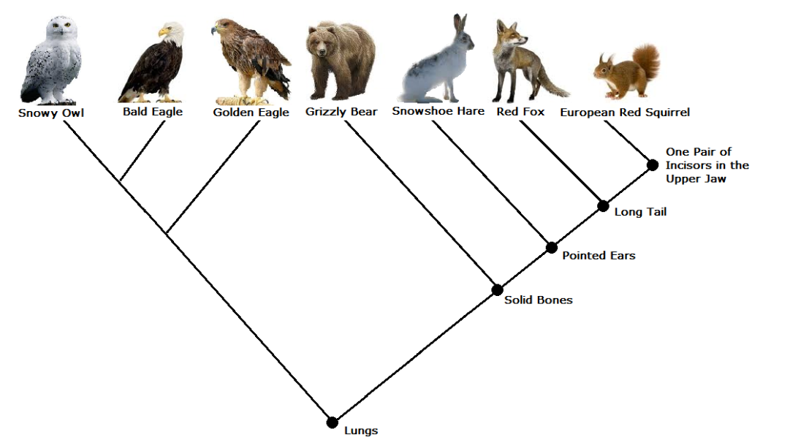
- According to the tree above, what adaptation evolved that allowed both birds and mammals to survive?
- Solid bones C. Lungs
- Long tail D. Pointed ears
- According to the tree above, what is the closest living relative of the European Red Squirrel?
- Red fox C. Grizzly bear
- Snowshoe Hair D. One pair of incisors in the upper jaw

- Order the current level of classification with the broadest group with a 1 and the narrowest with a seven.
______ Order
______ Kingdom
______ species
______ Family
______ Genus
______ Phylum
______ Class

- Which of the following scientific names are written correctly?
- Sciurus Carolinensis
- Sciurus Carolinesis
- Sciurus carolinesis
- Sciurus carolinesis

- Linnaeus is credited with introducing
- The concept of inheritance
- Law of limiting factor
- Theory of heredity
- Binomial nomenclature

- Having a standard taxonomic system benefits the scientific community by allowing scientists from all over the world to do which of the following?
- Have a common system for the classification of locations containing fossils
- Use a similar system to classify the impact of removing species from ecosystems
- Have a common understanding in the classification of organisms
- Understand how other scientists classify predator–prey relationships

- Some organisms have genes that improve their ability to survive and reproduce. If the genes also help their offspring survive and reproduce, then which of the following will most likely increase?
- The frequency of the genes in one individual
- The frequency of the genes in the population
- The number of genes in one chromosome
- The number of genes in the species

True or false:
- _________ All organisms with wings are closely related

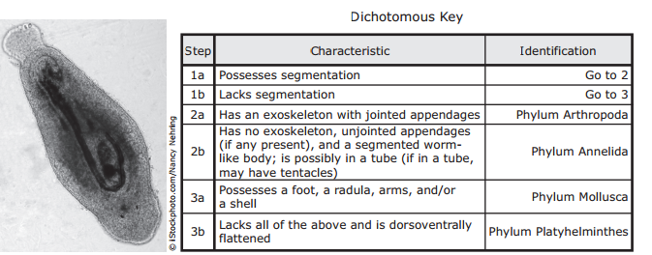
- A student collected the animal shown below on a field trip. The student used a dichotomous key and a microscope to classify the animal.

How should this animal be classified?
- Arthropoda
- Annelida
- Mollusca
- Platyhelminthes

- Which of the following are more closely related to the Eastern Cottontail Rabbit, Sylvilagus carolinesis?
  - Sylvilagus aquaticus
  - Thermus aquaticus
  - Carneufex carolinesis
  - Anolis carolinesis

- After examining the fossil record, scientists have determined that scorpions today are much smaller than their extinct ancestors. For example, Jaekelopterus rhenaniae, a giant scorpion species that lived 255 million to 460 million years ago, was 2.5 meters long. Which of the following conclusions is supported by this information?
  - Scorpions living today have increased their numbers since they first appeared
  - Scorpions in the fossil record are smaller than their descendants are.
  - Scorpions have changed as a result of natural selection
  - Scorpions do not appear in their original state in the fossil record.

- What three mechanisms directly affect/create differential reproductive success?
  - Competition, limited resources, more offspring than can survive
  - Competition, fitness, enough food in an area
  - Competition, genetic variation, limited resources
  - Competition, fitness, genetic mutations

Use the phylogenetic tree below to answer questions 11 and 12.
- According to the tree above, what adaptation evolved that allowed both birds and mammals to survive?
- Solid bones C. Lungs
- Long tail D. Pointed ears

- According to the tree above, what is the closest living relative of the European Red Squirrel?
- Red fox C. Grizzly bear
- Snowshoe Hair D. One pair of incisors in the upper jaw

- Which of the following individuals would be considered the fittest?
- A cottonwood tree that produces 1000 seeds but only 25 survive to reproduce.
- A dog with 2 pups and only one survives to reproduce.
- A large bull elk that successfully defends a large territory.
- An elephant that produces and cares for a single offspring once every five years.

- How are artificial selection and natural selection different?
- Only natural selection results in differential reproductive success.
- Artificial selection requires human intervention while natural selection doesn´t.
- Natural selection requires human intervention while artificial selection doesn´t.
- Only natural selection can lead to genetic changes in a species.

- Homologous structures are
- The result of a common ancestor
- Have the same function in different groups but don’t have a common ancestor
- Are the result of convergent evolution
- All of the above

- Pandas developed longer wrists to better eat bamboo over time and in turn increase their chance of survival. This is an example of:
  - Fitness
  - Comparative Anatomy
  - Artificial Selection
  - Adaptation

- The streamline shape of sharks and whales, similar but not due to a common ancestor is an example of:
  - Analogous traits
  - Homologous traits
  - Artificial selection
  - Fitness

- The overgrowth of algae poses a major problem for coral reefs. Intensive fishing is one factor that contributes to algae overgrowth because it does which of the following?
  - Allows more sunlight to be available to algae
  - Inhibits the spread of pathogens in algae colonies
  - Reduces the number of organisms that feed on algae
  - Increases the competition between different algae species

- What type of growth is represented by the J-shaped curve?
  - Sinusoidal
  - Linear
  - Exponential
  - Random
- You are studying a chain of islands in the Pacific Ocean. They are close together and have similar weather patterns, but some are larger than others. The largest islands will probably offer ____.
  - The most biodiversity
  - The least biodiversity
  - The largest population of one organism
  - One niche
- The first stage of succession of a forest after being decimated (destroyed) by a tornado would be
  - Mosses c. Grasses
  - Lichens d. Trees
- Which event is most likely to initiate primary succession?
  - Forest fire c. Logging
  - Heavy rain d. Volcanic eruption

- Cave dwelling fish having very reduced to no longer developing eyes is an example of
- Homologous structure
- Analogous structure
- Vestigial structure
- Convergent evolution
For the following questions pick whether the statement is best describing a homologous, analogous, or vestigial structure. Answers may be used more than once

- Homologous B. Analogous C. Vestigial

- ________ External structures are similar, but are not from a common ancestor
- ________ Remnants of ancestral structures that no longer serve a purpose
- ________ Internal structures are similar due to descent from a common ancestor
- ________Human’s tail bone
- ________ Wings of bats, insects, birds
- ________ Fore limbs of cat, bat, human, frog
- ________ pine needles, spines on a cactus, petals on daisy are modifications of a leaf derived from a common ancestor
- ________ pelvic bones found in whales and snakes
- ________ Mimicry between a Monarch butterfly and a Viceroy butterfly
- ________ Goosebumps in humans
- ________ tails and gills of human, chicken, and fish embryos

