Classroom Orientation for Mr. Aitken’s Students
I. Responsibilities
A norm is “a standard, model, or pattern.” In this class, we will take responsibility for upholding the standards of a respectful, positive environment by adhering to the following norms:
The Code of Cooperation*
- EVERY member is responsible for the progress and success of the class.
- Attend all class meetings, on time.
- Come prepared.
- Carry out assignments on schedule.
- Listen to and show respect for the contributions of other members.
- Avoid disruptive side conversations.
- Only one person speaks at a time.
- Ask questions when you do not understand.
- Attend to your personal comfort needs, but minimize class disruption.
- Have fun! *Adapted from the Boeing Airplane Group Team Member Training Manual

In short, “Do the right thing!!!

Academic honesty
Academic honesty should be a M.H.S. norm. ‘Cheating’ is any attempt to misrepresent your level of achievement or to aid another student in such an attempt. “We worked together” never produces nor justifies identical papers bearing different names. Reference your work. If you are unsure as to whether something is considered cheating, please ask – you won’t be penalized for asking. Cheating will earn a zero on the assignment, a call home, and referral to the administration. Read the section on cheating in the MHS Handbook.
II. Procedures From A to Z
Operating procedures are used in the workplace to make sure that things run smoothly. Knowing the procedures for our class enables you to maximize your learning time.
Absence Our class is a performance class – regular attendance is crucial for student success. If you
(Excused) are absent for a day, YOU are responsible for finding out what took place in class by checking
your lab partner or me and obtaining missed handouts from the handouts file on the class website. See Making Up Missed Work.

Attention If you are busy working in groups & I need everyone’s attention, I will stand near the front of the room with my hand in the air and ask for attention. When this happens, please stop talking and turn towards me for further instructions.

Begin class Please be on time so you can read the agenda on the board & prepare for the day’s lesson.

Dismissal I need the last few minutes of class to monitor clean up or clarify any misconceptions. Thus, after final instructions are given & the room is clean, I – not the bell – will dismiss our class.
Contacting You or your parents/guardians are welcome to e-mail (aaitken@tipton-county.com), call (901.836.5701), I will try to respond within 48 h. E-mail is easiest!

Electronic There will be times cell phones will be used in class. However, when not being used for academic purposed, cell phones will be placed in the corresponding cell phone slot till needed.

Help I hold optional after-school Help Sessions most weeks, usually on Tuesday afternoon.
Sessions I also have an open door policy, meaning if I’m here a student can receive help.
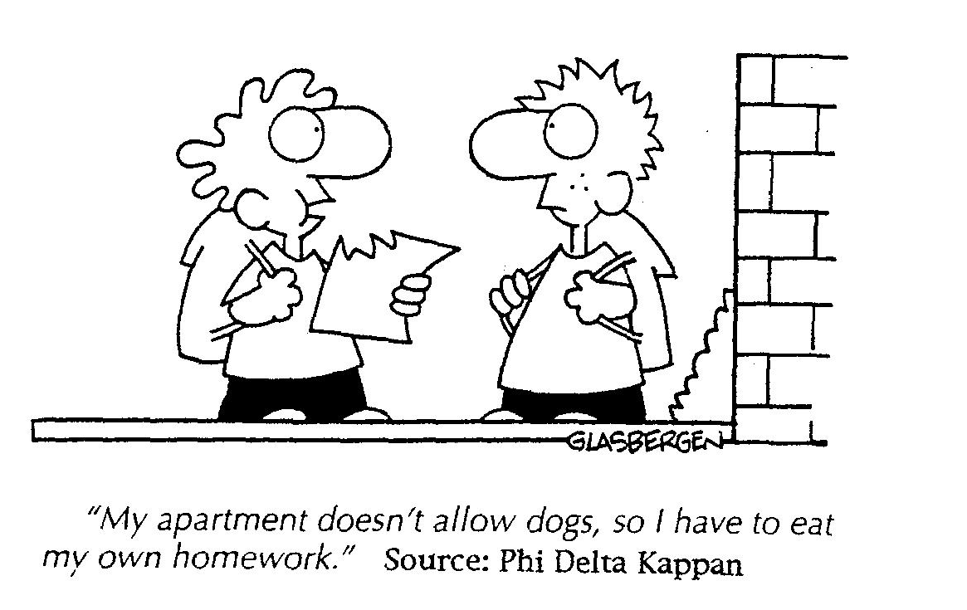
Homework Homework is not given often and is usually work that could have been completed in class. Homework should be completed and turned in by the next class session.

Late Work Late work, though strongly discouraged, will be accepted ONE class day later without a penalty. If turned in more than one class day later, the work will be accepted for half credit.

Making Up • Missed homework – Complete it within a grace period equal to the length of the absence.
Missed In other words, if you are absent one day, you have one extra day to turn in the work.
Work from
an Excused
Absence • Missed quiz – The quiz score is usually prorated using your next quiz as the replacement quiz score. See syllabus for more details.

• Missed lab – If data was collected and group’s data had to be used, 50% penalty will be enforced out of fairness for those who did the work. If lab is impractical to make up, an optional 4 page typed paper will be given due one week from missed lab at student’s discretion. Due to safety issues and lack of space, there are rarely make-up labs.

• Missed exam – Taken the next day either in class or in ISP.

Pass List If late to class, using a pass for a restroom emergency, or leaving with an early dismissal, sign
the pass list on the clipboard by the door. Remember…. passes are privileges.

Pre-Lab A pre-lab assignment prepares a student to SAFELY work in the laboratory. Therefore, choosing not to complete the pre-lab means that the student cannot do the lab. S/he will spend the period performing classroom service or book work instead.

Publishing When instructed to publish an assignment, please revise the work and turn it in on lined, unlined, or graph paper (as appropriate) instead of completing it in your journal.

Substitutes The Code of Cooperation and all classroom procedures are in effect when we have a guest (substitute) teacher. As they say at WSDOT, “consequences double in guest teacher zones.”

Tardy If unexcused tardy, student will sign clipboard. Three unexcused will result in a referral slip

Website Visit me on the Web at http://aaitken.weebly.com. You can access the class home page where you can access old quizzes, view study material, or leave me an e-mail message.

Z “Z end!” Thank you for reading!

