Cellular Unit exam

This exam is worth 216 points out of a possible 221 points. Please read through each question and answer each to the best of your ability. A good test taking strategy is to write down any charts or diagrams you know now, next read through all the questions; then try to think of the answer before looking at the possible answer choices to see which of the choices best fits your initial answer. Be confident and trust your gut. I have faith in you and I want you to have confidence and faith in yourself. Take a deep breath and answer the questions that you think are easy first and come back to the harder ones. You got this now, go get it…

- A type of cell that contains a nucleus is classified as a _____?
- Lipid
- Prokaryote
- Eukaryote
- Proteinase

- A prokaryotic cell does NOT contain?
- Chloroplast and DNA
- Cell Wall and DNA
- Nucleus and Chloroplast
- Cell membrane and Nucleus
- None of the above

- In what organelle would DNA be found?
- Cell membrane
- Ribosome
- Smooth ER
- Nucleus
- None of the above

- The illustration shows the movement of oxygen (star) into a cell. What process is shown?

- Diffusion
- Active Transport
- Photosynthesis
- Protein Channeling

Higher concentration outside Substance moves into cell

A typical plant cell is shown below.
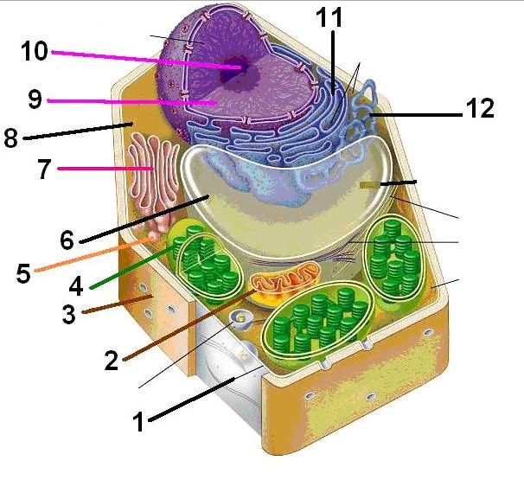
- Which organelle is responsible for generating energy?
- Organelle 1
- Organelle 2
- Organelle 3
- Organelle 4
- None of the above

- Which organelle is responsible for making ribosomes?
- Organelle 7
- Organelle 8
- Organelle 9
- Organelle 10
- None of the above

- Which organelle is responsible for allowing plants to undergo photosynthesis
- Organelle 2
- Organelle 3
- Organelle 4
- Organelle 6
- None of the above

- Which cell organelle is correctly matched to its function?
- Lysosome- stores materials C. Cytoskeleton- supports cell shape
- Ribosome- converts energy D. Chloroplast- transports material

- While lifting weights, muscle cells consume large amounts of energy. Which organelles increase their activity in muscle cells during weight training to make more energy available?
- Nucleus
- Ribosome
- Mitochondria
- Golgi bodies
- Which function in prokaryotic and eukaryotic cells is accomplished differently in the two cell types?
- Storage of hereditary information
- Separation of the cell from its environment
- Breakdown of energy-storage molecules for energy use
- Use of hereditary information to guide construction of proteins

Match the term its correct description.
  - Energy d. Active transport
  - Facilitated diffusion e. Osmosis
  - Passive transport

- _____ The diffusion of water through a cell membrane
- _____ Is a characteristic of active transport but not passive transport
- _____ Movement of particles down a concentration gradient with the help of substances to enter or exit the cell membrane
- _____ When molecules move from areas of high concentration to areas of low concentration
- _____ When energy is required to move materials through a cell membrane against their concentration gradient

- While viewing a slide of rapidly moving sperm cells, you conclude that sperm cells require a large amount of energy to maintain their activity. The ______ provides the energy needed for the ________ to propel the cell.

- Ribosome: flagella
- Ribosome: cilia
- Mitochondria: flagella
- Mitochondria: Smooth ER
- None of the above

- What two structures would you look for under a microscope to determine if a cell was from a plant cell?
- Lysosome and nucleus
- Vacuole and cytoplasm
- Chloroplast and cell wall
- Lysosome and vacuole

- In a cell’s environment, materials move in and out of the cell. Which process is an example of active transport?
- Glucose molecules in the bloodstream move through proteins in the cell membrane.
- Potassium ions move across a cell membrane to the side of higher concentration
- Dissolved carbon dioxide gas from mitochondria diffuse throughout a cell
- Water moves from a high concentration to lower concentration.

- Bacteria and Archaea are classified as prokaryotic cells because they

- Do not require oxygen to perform cellular respiration
- Contain a protein bilayer and non-membrane bound ribosomes
- Contain genetic information required for them adapt
- Lack membrane-bound nuclei

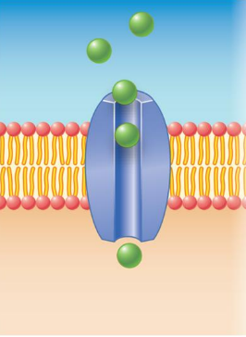
- The model on the right shows small molecules moving through a large “porous” opening. What kind of macromolecule would you expect the opening to be?

- Phospholipid
- Carbohydrate
- Nucleic Acid
- Protein

- Membrane phospholipids

- Have hydrophilic heads that face outward and are exposed to water
- Have hydrophobic tails that face inward and are shielded from water
- Both A & B are correct
- None of the above

- The fluid mosaic model describes the plasma membrane consisting of

- Two layers of phospholipids with protein sandwiched between them
- A protein bilayer with embedded phospholipids
- A phospholipid single layer with embedded proteins
- A phospholipid bilayer with proteins going through the bilayer
- None of the above

- Glucose diffuses very slowly through a synthetic phospholipid bilayers. The cells lining the small intestines are able to move large quantities of glucose from the sugar-rich food we eat into the glucose-poor cytoplasm. From this information, which transport mechanism is most probably functioning in this process of the intestinal cells?

- Simple diffusion
- Active Transport
- Osmosis
- Facilitated diffusion
- None of the above

- An animal cell lacking carbohydrates on the external surface of some glycoproteins in the plasma membrane would be impaired in which function?

- Transporting ions against an electrochemical gradient
- Maintaining fluidity and lubrication
- Cell-Cell recognition
- Defending the plasma membrane from foreign invaders

- What is the outer boundary of the cell called?

- Nuclear Membrane
- Endoplasmic Reticulum
- Cell membrane
- Nucleolus

- Which of the following would NOT be found in an animal cell’s plasma membrane?

- Glycoproteins
- Phospholipids
- Cholesterol
- Glycolipids
- Nucleic Acids

- You would expect a cell with an extensive Golgi complex to be to
- Make a lot of ATP.
- Secrete lots of materials.
- Move actively.
- Perform photosynthesis.
- Store large quantities of food

- A cell has mitochondria, ribosomes, smooth and rough ER, and other parts. Based on this information, it could NOT be

- A cell from a pine tree
- A grasshopper cell
- A yeast (fungus) cell
- A bacteria cell
- Actually, it could be any of these

- People should not drink salt water. How does drinking salt water affect the cells in the body?
- Water flows in the cells and the cells expand
- Water flows out of the cells and the cells shrink
- The cell membrane prevents water flow and pumps salt in
- The cell membrane allows water to flow and pumps salt out

- The illustration is a representation of the different ways molecules are transported across a cell membrane
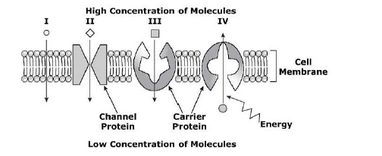
Which part of the illustration represents active transport?
- I
- II
- III
- IV

- How does the channel protein to right aid in the movement of particles through the cell membrane?
- It helps ions to bond and form larger compounds inside the cell
- It causes ions inside the cell to attract water molecules from outside the cell
- It enables ions to be removed from the cell against the concentration gradient
- It allows ionic compounds to move freely through the membrane to reach equilibrium
Matching
a. | Golgi apparatus | d. | Vacuole
b. | Endoplasmic reticulum | e. | Cytoplasm
c. | Lysosomes

- _____ Jelly-like material found in the cell. Contains organelles & where most cell processes take place
- _____ Involved in intracellular digestion
- _____ Stores water, salt and other molecules. Oversized in plants to create turgid pressure
- _____ Modifies, sorts and packages cellular materials

- A cell transports materials through the cell membrane either passively (without energy). Which cellular process demonstrates the movement of materials that requires a source of energy?

- Transport proteins move molecules through the cell membrane to an area of higher concentration inside the cell
- Water moves through channels in the cell membrane to an area of lower concentration out the cell
- Particles move through the cell membrane to an area of lower concentration inside the cell
- Carrier proteins provide a channel for the movement of glucose inside the cell

- What will most likely be the result if all of the mitochondria in a plant cell were removed?
- It will be unable to carry out respiration
- It will lose water through osmosis
- It will break down the ribosomes in the cell
- It will be unable to photosynthesize

Graveyard: The following multiple choice questions are worth five points apiece and cover older material we have discussed that was not in chapter seven. Take a breath, now another one. You’re nearing the end of the exam, but do well on this section or it could kill you.

- A certain enzyme will hydrolyze (bind with) egg whites, but not starch. Which statement best explains this observation?
- Starch molecules are too large to be hydrolyzed
- Enzymes molecules are specific in their action
- Egg white acts as a coenzyme for hydrolysis
- Starch is composed of amino acids

- Which of the following are building blocks of lipids
- Fatty acids
- Mono-saccharides
- Nucleotides
- Peptides

- You are analyzing a compound in a laboratory. You find that it is made up of carbon, hydrogen, and oxygen in ratio of two hydrogen atoms for each carbon atom. How will you classify the compound?
- Lipid
- Carbohydrate
- Protein
- Nucleic acid

- Lactase is an enzyme that converts lactose to glucose and fructose. The figure below shows the activity of lactase as the concentration of lactose is increased.
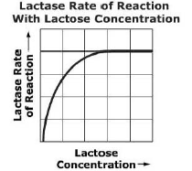

Why does the rate of reaction slow and eventually become constant?
- The enzyme has become saturated (think of wet sponge)
- The enzyme has become denatured
- The enzyme is interfered with by glucose
- The enzyme does not enough lactose to react with

- Students are testing organic compounds in unknown solutions. A student uses Benedict’s reagent to test an unknown and observed the solution turned red-orange throughout the solution. What can you conclude about the solution based off the students’ test?
- The students’ did something wrong
- The solution contained proteins
- The solution contained starch
- The solution contained sugars

- A researcher is studying the effect of sleep on aggression, thinking that less sleep will lead to more aggression. She has some people sleep 6 hours per night, some people sleep 3 hours per night and some people sleep as much as they want. She then monitors aggressive behavior during basketball games among participants. Identify the independent variable and the dependent variable that you would use to test this hypothesis.

- DV- amount of sleep / IV- aggression
- DV- aggression/IV-amount of sleep
- DV- basketball games/ IV- participants
- DV- participants/ IV- basketball game

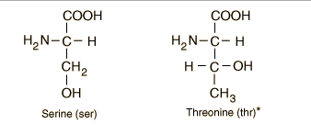
- What would you call the result of chaining/binding many of these molecules to the right together?
- Carbohydrates
- Lipids
- Protein
- Nucleic Acids

- Which statement best describes the enzyme represented in the graphs below?
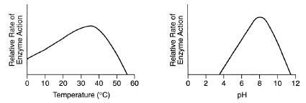
A. This enzyme works best at a temperature of 35°C and a pH of 8
B. This enzyme works best at a temperature of 50°C and a pH of 12
C. Temperature and pH have no influence on the activity of this enzyme
D. This enzyme works best at a temperature above 50°C and a pH of 12

- As food travels through the digestive system, it is exposed to a variety of pH levels. The stomach has a pH of 2 and the intestines have a pH that ranges from 7-9. Hydrochloric acid in the stomach converts pepsinogen into pepsin (enzyme that breaks down proteins). Which of the following most likely explains what happens to the pepsin as it enters the small intestines?
- It becomes denatured and inactive
- It begins to replicate
- It changes shape to swallow large proteins and digest them
- It becomes more active and breaks down proteins faster

The diagram below shows a macromolecule.
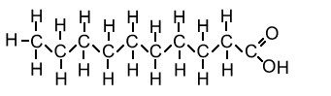
- How would you classify the macromolecule above?

- Carbohydrate
- Lipid
- Protein
- Nucleic Acid

- What is one of the functions of the macromolecule shown above?

- Energy storage
- Structural support
- Regulating cellular functions
- Speeding up chemical reactions

- What are the building blocks of protein?
- Fatty acids
- Glycerol
- Enzymes
- Amino acids

- All organisms contain four organic molecules. Which group of molecules contains fatty acids and glycerol, is insoluble in water (hydrophobic), and functions in long-term energy storage?
- Carbohydrates
- Nucleic Acids
- Proteins
- Lipids

The graph below shows the conversion of a reactant into a product.
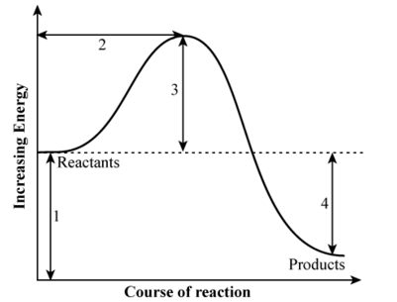
- Which of the labeled parts of the graph correctly shows the activation energy required for the reaction?
- 1
- 2
- 3
- 4

- Which procedure is a scientific method?
- Collecting data
- Formulating a hypothesis
- observation
- Actually, all are correct

- How can the relationship between photosynthesis and cellular respiration best be described?
- Cellular respiration produces oxygen that is in turn used by photosynthesis
- Carbon dioxide is produced by photosynthesis that is turn used in cellular respiration
- Photosynthesis produces glucose that is in turn used in cellular respiration
- Cellular respiration stores energy for future use by cells and photosynthesis releases energy for use in cellular reactions.

- Use the chart below and your knowledge of enzymes to answer the question.
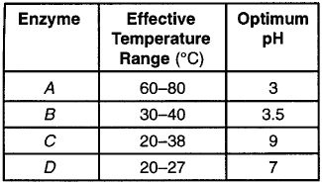
Which enzyme would most likely be functional in bacteria living in a hot spring that is 35°C above normal human body temperature?
- Enzyme A
- Enzyme B
- Enzyme C
- Enzyme D

- Maltase is an enzyme found in some cells. The diagram below shows the activity of maltase.
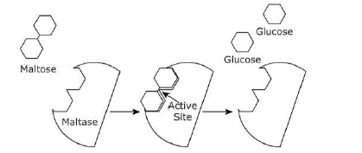
What is the function of maltase in the cell?
- Produces maltose from glucose
- Inhibits the production of glucose
- Eliminates glucose waste products
- Breaks the bond between glucose molecules

- Inside the body, heat is constantly being generated as a byproduct of necessary chemical reactions. Humans must be able to release heat to the environment. This adaptation is necessary for maintaining _______.
- Energy C. Homeostasis
- Organization D. Locomotion

- The table below shows nine substances tested for biomolecules.

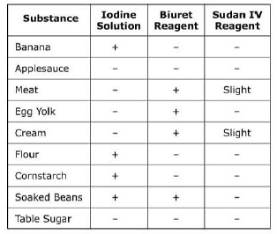
Which substance contains protein and starch?
- Banana
- Egg Yolk
- Soaked Beans
- Table Sugar

- The fact that amylase in the human small intestine works best at normal body temperature 37°C suggests that
- Amylase is denatured at temperatures below 37°C
- Amylase can only function in the small intestine
- The lock-and-key model of enzyme action does not apply to amylase
- The optimum temperature for amylase is 37°C

- Enzymes are catalysts. How do enzymes increase the reaction rate?
- Transfer inhibitors away from reactants
- Provide an active site for substrates to react with
- Transfer substrates to ribosome
- Provide energy to reactants

- Which of the following molecules best represents a nucleotide?
- 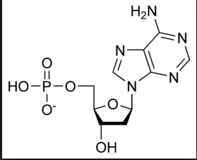

- 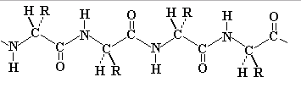

- 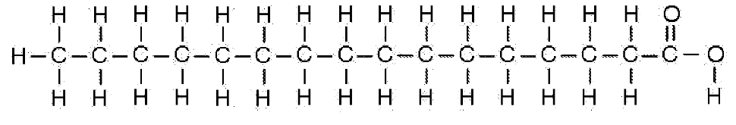

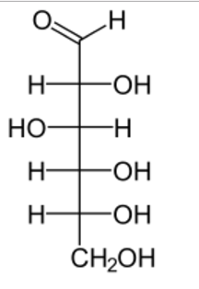

**Bonus**
- What type of cell do many scientists hypothesize to be older, prokaryotes or eukaryotes (2pt)? Defend your answer by either writing or drawing your reasoning (3pts).

