SURFIN’ THROUGH STAAR
Session 2: Cellular Processes

Background Information: Cell Transport
When molecules move from a high to low concentration it is called moving DOWN the concentration gradient.
When molecules move from a low to high concentration it is called moving AGAINST the concentration gradient.
When the concentration of a solute is the same throughout a system, the system is at EQUILIBRIUM.
What kind of transport DOES NOT require energy? PASSIVE What kind of transport requires energy? ACTIVE
Which CELL PART provides the energy for active transport? MITOCHONDRIA
Which MOLECULE is produced by mitochondria and provides energy for transport? ATP
Movement of molecules FROM a region of HIGH concentration TO a region of LOW concentration = DIFFUSION
The movement of molecules FROM a region of HIGH concentration TO a region of LOW concentration with the HELP of carrier proteins or channels = FACILITATED DIFFUSION
Membrane proteins that move molecules across membranes by attaching, changing shape, and flipping to the other side like a revolving door = CARRIER PROTEINS
Membrane proteins that help molecules across membranes by providing a tunnel = PROTEIN CHANNELS
The movement of WATER molecules from HIGH concentration to LOW concentration across a cell membrane = OSMOSIS
Which kinds of transport use VESICLES to help molecules across membranes? ENDOCYTOSIS (PHAGOCYTOSIS & PINOCYTOSIS & EXOCYTOSIS
Stage 3

Stages 1 & 2

Photosynthesis Chemical Reaction for photosynthesis:
Water + Carbon dioxide → Glucose + Oxygen
6H₂O + 6CO₂ → C₆H₁₂O₆ + 6O₂

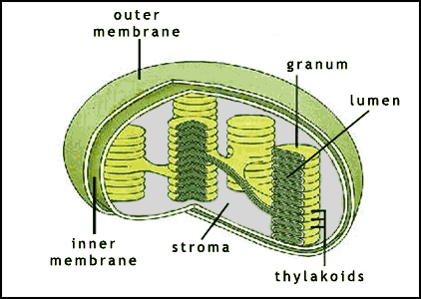
Process by which plants and some other organisms use light energy to convert water and carbon dioxide into oxygen and high-energy carbohydrates such as sugars and starches
Chloroplast- site of photosynthesis

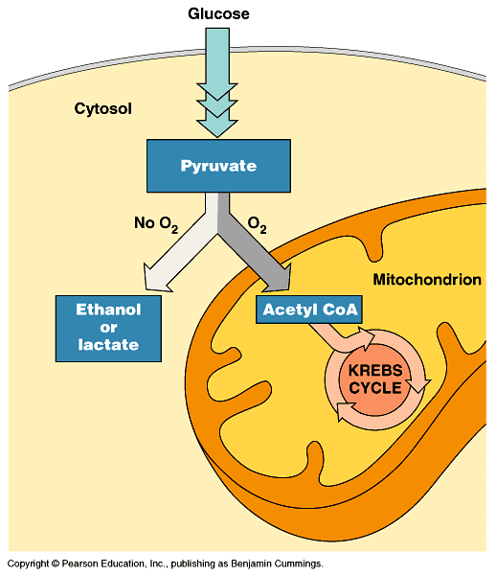
Cellular Respiration- process that releases energy by breaking down glucose and other food molecules in the presence of oxygen; Aerobic means with oxygen (O₂); Anaerobic means without oxygen (O₂)
-Glycolysis- Means the splitting of glucose; Occurs in the cytoplasm of all cells in every organism; It does NOT require oxygen; A net of 2 ATP is made during glycolysis.
-Fermentation – Anaerobic Pathway-There are 2 types of fermentation: Alcoholic Fermentation-Occurs in yeasts and bacteria, CO₂ and ethyl alcohol are produced (bread dough rising); Lactic Acid Fermentation-Occurs during strenuous exercise (burning & fatigue in muscles)
-Cellular Respiration Totals: Energy produced per glucose molecule; -Glycolysis = Net of 2 ATP; Kreb’s Cycle = 2 ATP; Electron Transport Chain (ETC) = 32 ATP; Total = 36 ATP per glucose molecule
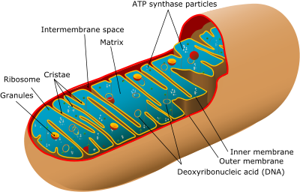
Mitochondria “powerhouse”- site of cellular respiration= MAKING ENERGY! Manages the process by which energy stored in food molecules is transformed into usable energy for the cell.

Other cell organelles:
Vacuole- stores water, waster, enzymes and other materials
(like a water tower)
Golgi body- sorts and packages proteins (think of UPS)
Nucleus- brain/control center of the cell; instructions for making proteins
Lysosome- digests worn out organelles, food particles, and engulfed bacteria & viruses (like a janitor/clean up crew)
Ribosome- site of protein synthesis (think of meat-has protein in it)
Cell membrane- controls what enter and leaves the cell, “semi or selectively permeable” (like a bouncer)
Mitosis: produces 2 genetically identical, diploid body (somatic) cells Diploid: full set of chromosomes
Meiosis: produces 4 genetically different, haploid sex (gametes) cells Haploid: chromosome # is half

Practice Questions:

Cell organelles carry out specific metabolic processes.

1. Study the statement above. Which cell organelle manages the process by which proteins are sorted and packaged to be sent where they are needed?
a. ribosomes b. lysosomes c. Golgi bodies d. vacuoles

2. Study the statement above. Which cell organelle is responsible for storing enzymes and other materials needed by the cell?
a. ribosomes b. vacuoles c. mitochondria d. lysosomes

3. Study the statement above. Which cell organelle manages the process by which proteins are assembled based on DNA instructions?
a. mitochondria b. lysosomes c. ribosomes d. vacuoles

4. Study the statement above. Which cell organelle manages the process by which energy stored in food molecules is transformed into usable energy for the cell?
a. lysosomes b. golgi bodies c. mitochondria d. ribosomes

5. Study the statement above. Which cell organelle manages the process by which worn out organelles, food particles, and engulfed viruses or bacteria are digested?
a. ribosomes b. lysosomes c. vacuoles d. golgi bodies

6. Which of these is not an advantage gained by organisms which reproduce sexually?
a. Genetic recombination created genetic diversity within a species.
b. Some percentage of organisms within a species will be likely to survive and reproduce despite harsh environmental conditions.
c. Genetic diversity reduces the risk of species extinction caused by hard environmental conditions.
d. Genetic diversity weakens a species’ overall ability to survive harsh environmental conditions.

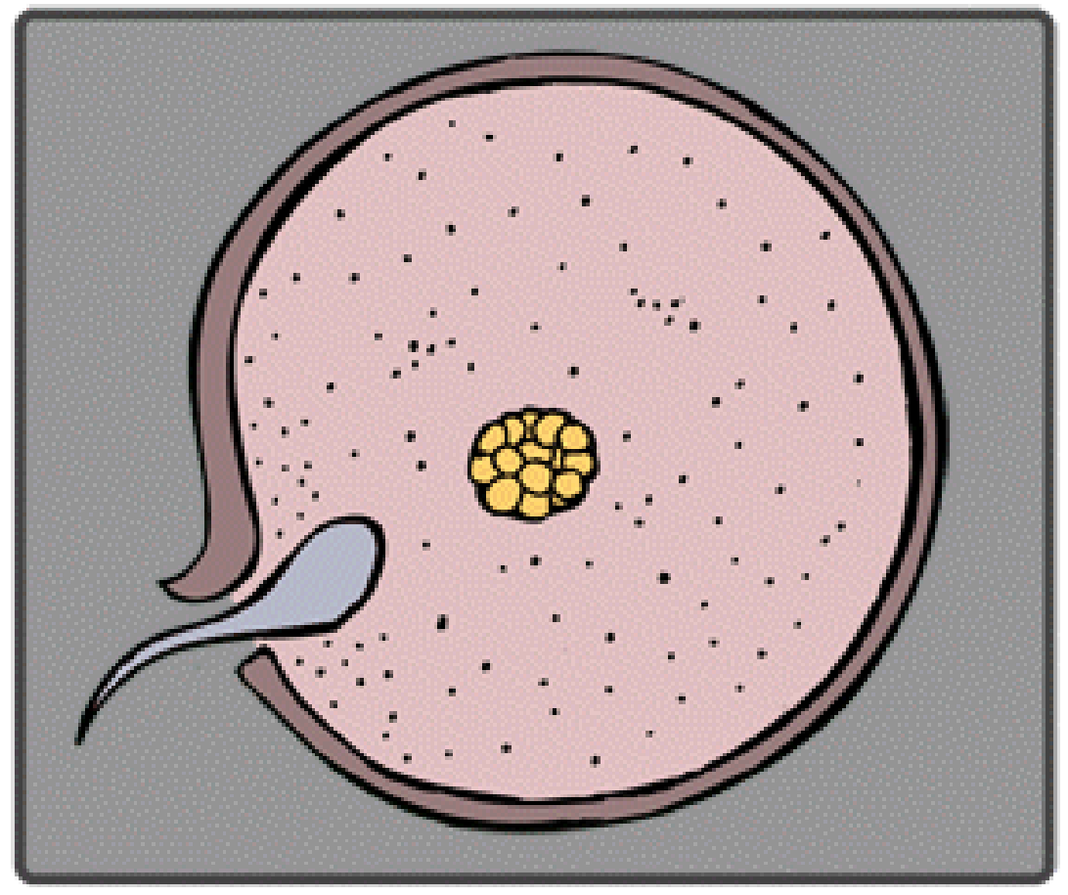
7. A fertilized egg created through sexual reproduction-
a. has a combination of genetic material that is unique in the species
b. is genetically identical to other eggs of the same parents
c. is genetically identical to the parents
d. contains genetic material from only one parent

8. Organisms reproduce asexually in a variety of ways. A bacterium reproduces by making a copy of its chromosome, growing larger, then dividing into two separate, genetically identical cells. This process is called-
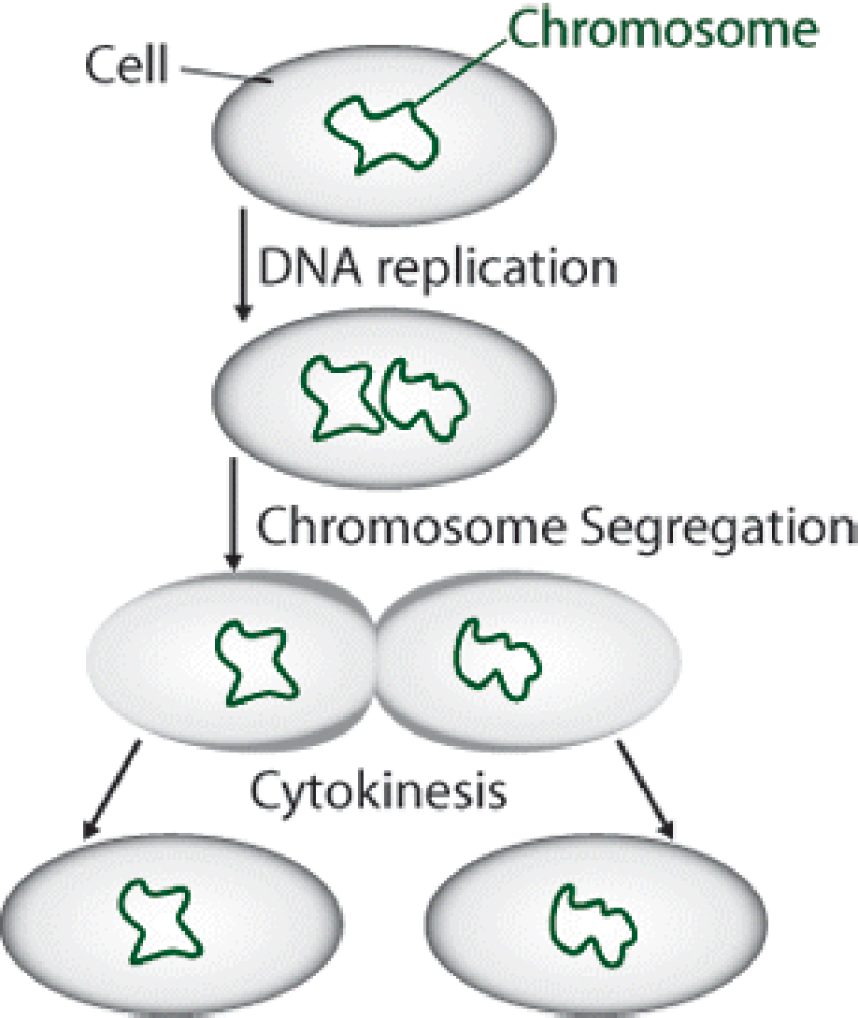

a. regeneration b. binary fission c. vegetative reproduction d. budding

9. Which of the following statements about sexual reproduction is false?
a. Organisms that reproduce sexually produce sex cells called gametes.
b. Fertilization is part of the sexual reproduction process.
c. In sexual reproduction, a single parent produces identical offspring.
d. A zygote is produced through sexual reproduction.

10. Study the chemical reactions below.

Photosynthesis:
Cellular respiration:
Plants produce more oxygen during photosynthesis than they use in cellular respiration. What happens to the excess oxygen produced during photosynthesis?
a. It is used as an energy source by plant cells.
b. It is released into the air and is used by other organisms for respiration.
c. It is converted into heat energy.
d. It is a waste product which is never reused.

11. Which of these is inhaled by animals, then used in respiration?
a. carbon b. oxygen c. nitrogen d. water

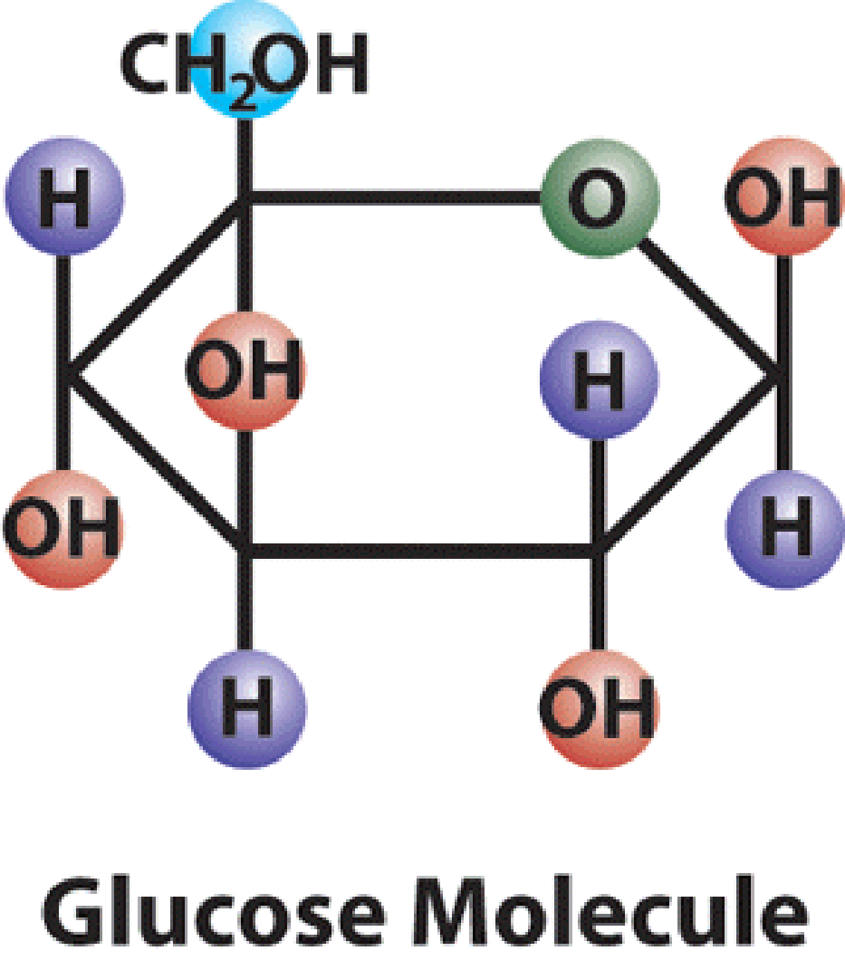
12. One of the products of photosynthesis is glucose (C₆H₁₂O₆). Which of the following statements about the production and use of this molecule is false?
a. Plants use the energy from glucose to convert nutrients to body tissues and grow larger.
b. Glucose that is not immediately used by the plant is stored for later use.
c. Plants use the energy from glucose to manufacture a variety of plant products.
d. Glucose that is not immediately used by the plant is lost as waste material.

13. Tigers, goldfish, peacocks, and humans all reproduce sexually. Which statement is true about sexual reproduction?
a. It is not a factor scientists use to define different species.
b. It involves the joining of an egg and sperm into one cell.
c. The offspring are genetically the same as their parents.
d. Sexual reproduction can only take place by internal fertilization.

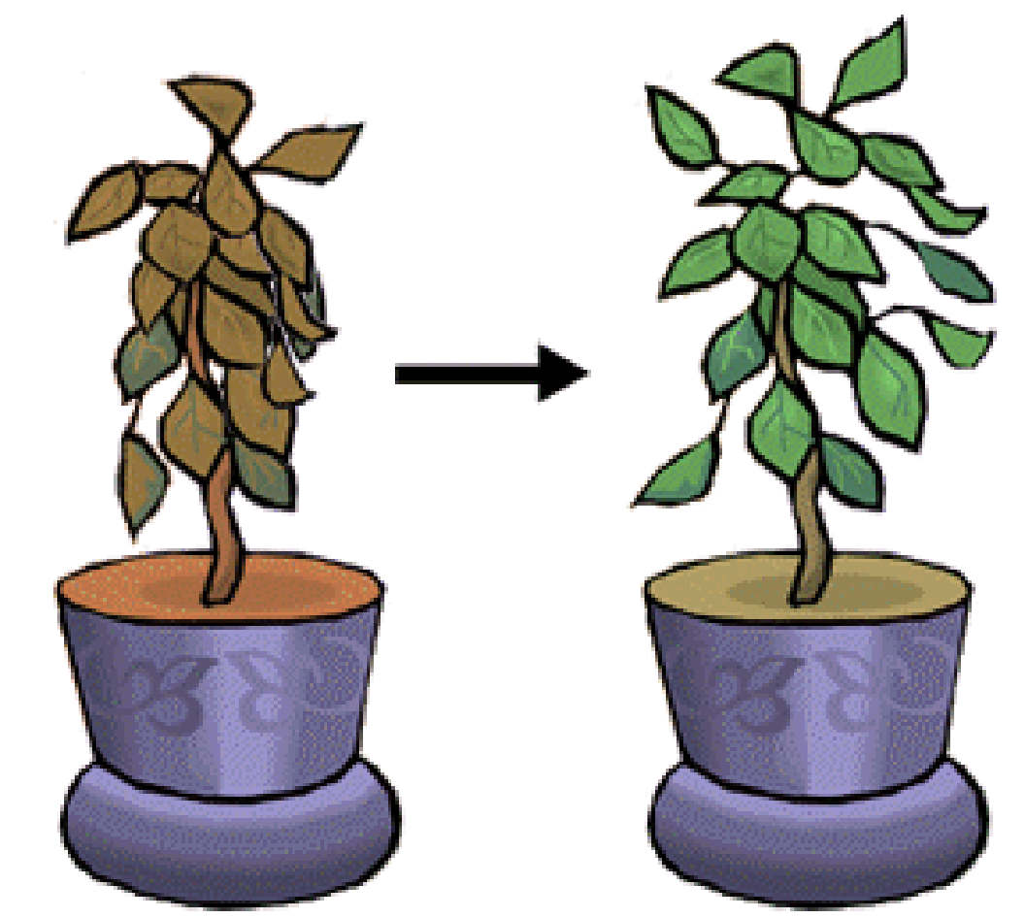
14. Jackson is growing a bean plant in a pot. One day Jackson notices that the plant is wilting. He waters the bean plant and within a few minutes the plant begins to perk up. This is because the plant has taken up water by osmosis. At what structural level does osmosis occur?
a. organs
b. tissues
c. cells
d. organ systems

Organisms as different as bacteria, mushrooms, algae, oak trees, and human beings are all made of cells.

15. Read the information above. Which statement is true for all cells?
a. All cells have the same shape.
b. All cells need energy to survive.
c. All cells are surrounded by a rigid wall.
d. All cells belong to organ systems.
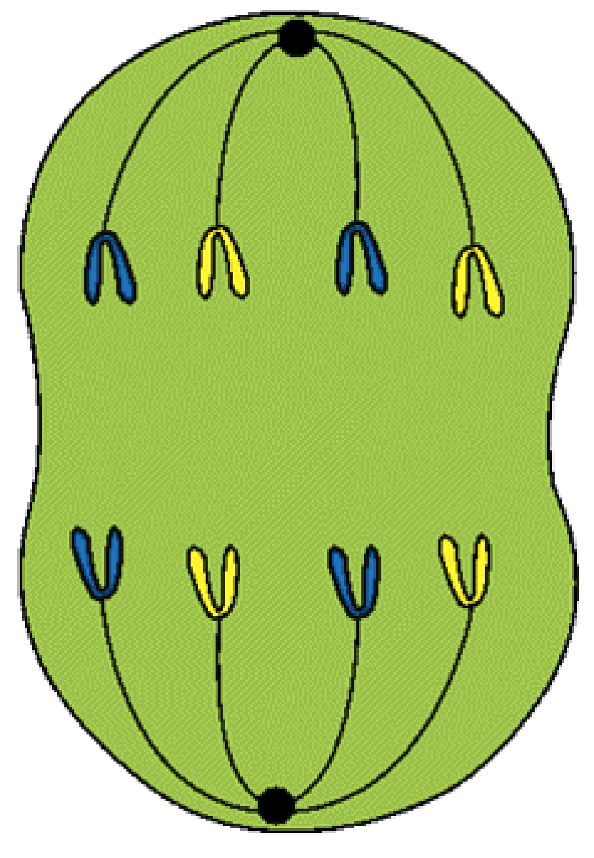
Michelle is looking through a microscope at a cell from an onion root. She sees a cell that is in the process of dividing to make a new cell. This is what Michelle sees:

16. Study the diagram and the description above. If Michelle were able to find an onion cell that had completed division, what products of cell division would she see?
a. four different cells b. only one cell c. two identical cells d. four identical cells

17. Study the diagram and the statement above. Michelle is observing cell division in an onion cell, but this type of cell division also occurs in the human body. Which statement is not true about this type of cell division in humans?
a. This type of cell division is humans produces sex cells as well as body cells.
b. This type of cell division in humans occurs while bones are forming during development.
c. This type of cell division in humans can be affected by viruses.
d. This type of cell division in humans is necessary to heal cuts and wounds

18. Study the diagram and the description above. What is the name for the process Michelle is observing?
a. mutation b. meiosis c. mitosis d. metamorphosis

19. Study the diagram and the information above. Which of these statements about cell division is true?
a. A newly formed daughter cell has less DNA than its parent cell.
b. Cells divide at random times.
c. New cells formed by cell division can replace dying cells in an organism.
d. The phases of cell division can occur in any order.

20. A special type of cell division, called meiosis, is used to form sex cells or gametes. Which statement is true above this type of cell division?

a. The products of meiosis are two identical cells.
b. DNA is not copied at all during meiosis.
c. The new cells have half the DNA of the parent cell.
d. Meiosis is complete after only one round of cell division.

21. A person with swollen gums rinses his mouth with warm salt water, and the swelling decreases. Which has occurred?
a. The swollen gums have absorbed the saltwater solution.
b. The saltwater solution lowers the temperature of the water in the gums.
c. The salt in the solution has moved against the concentration gradient.
d. The water in the gums has moved from a high to a low concentration of water.

22. What advantage do sexually reproducing organisms have over asexually reproducing organisms?
a. genetic variation b. genetic stability c. increased fertilization rate d. increased reproductive rate

23. What is the most likely function of a group of cells that contain a high number of chloroplasts?
a. respiration b. transpiration c. fermentation d. photosynthesis

24. In humans, glucose is kept in balance in the bloodstream by insulin. Which concept does this best illustrate?
a. adaptation b. homeostasis c. metabolism d. organization

25. In which way are photosynthesis and cellular respiration different?
a. Cellular respiration stores ATP, while photosynthesis releases ATP.
b. Cellular respiration produces oxygen, while photosynthesis uses oxygen.
c. Photosynthesis releases energy, while cellular respiration stores energy.
d. Photosynthesis uses carbon dioxide, while cellular respiration produces carbon dioxide.
26. Which statement best distinguishes aerobic from anaerobic respiration?
a. Only aerobic respiration involves fermentation.
b. Only anaerobic respiration occurs in the mitochondria.
c. Only aerobic respiration requires oxygen.
d. Only anaerobic respiration produces carbon dioxide.

27. Which most accurately describes the difference in ATP production between aerobic respiration and anaerobic respiration?
a. Aerobic respiration produces more ATP than anaerobic respiration.
b. Anaerobic respiration produces more ATP than aerobic respiration.
c. Only anaerobic respiration produces measurable amounts of ATP.
d. Anaerobic and aerobic respiration produce the same amount of ATP.

28. A human skin cell contains 46 chromosomes. How many chromosomes are present in a human sperm cell?
a. 23 b. 46 c. 92 d. 138

29. What is homeostasis?
a. the ability of an organism to maintain a relatively stable internal environment
b. the production of a hormone by an endocrine gland that works on another endocrine gland
c. a series of events that monitor how hormones work in the body
d. a process in which a change in the environment causes a response that returns conditions to their original status

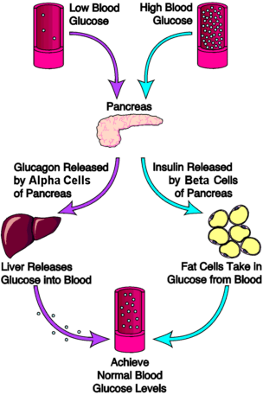

30. If the body stopped producing new Beta cells, what would the expected outcome be?
- The pancreas would no longer release glucagon
- High blood glucose levels would continue
to become normal
- Insulin would no longer be released
- Alpha cells would become beta cells

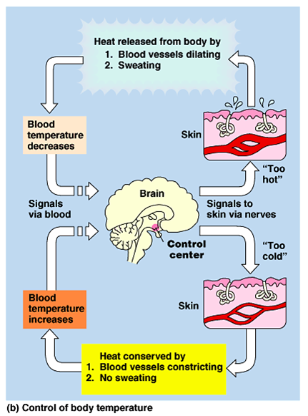

31. You just ran a marathon (26.2 miles) and your body is trying to reach homeostasis.
Which of the following statements is true?
- Your blood vessels will constrict to conserve heat
- Your blood vessels will dilate to release body heat
- Your body’s control center will shut down
- Your brain will tell your body not to sweat

