**Mitosis and Meiosis Quiz I**

1. Cells must remain small which is why they undergo mitosis. Which of the following is a reason why a cell must remain small?
   1. It is efficient for a cell to have a large volume.
   2. Cells need to transport nutrients and wastes into and out of the cell in a quick and efficient way.
   3. Communication will take longer between neighboring cells.
   4. None of the above are reasons why a cell must remain small.
2. **Multicellular organisms use mitosis for growth, development and**
3. **apoptosis**
4. **repair/healing**
5. 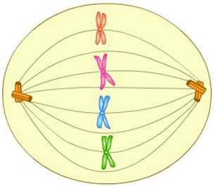**sexual reproduction**
6. **interphase**
7. In the diagram on the right, what is the term used to describe the structures that are lined up in the middle of the cell?
8. Centrioles in Prophase I
9. Homologous Chromosomes in Metaphase I
10. Sister Chromatids/Chromosome in Metaphase
11. Gametes in Cytokinesis
12. Mitosis starts with 1 cell and results in __________, while meiosis starts with 1 cell and results in __________.
    1. 2 somatic cells; 2 gametes
    2. 2 gametes; 2 somatic cells
    3. 2 somatic cells; 4 gametes
    4. 2 gametes; 4 somatic cells
13. How does mitosis differ from meiosis?
    1. Mitosis results in identical diploid cells whereas Meiosis results in haploid cells that are genetically different.
    2. Mitosis results in haploid cells that are genetically different whereas Meiosis results in identical diploid cells.
    3. Mitosis results in identical haploid cells whereas Meiosis results in diploid cells that are genetically different.
    4. Mitosis results in diploid cells that are genetically different whereas Meiosis results in identical haploid cells.

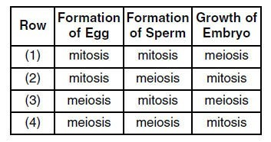

1. Which row in the chart on the right indicates the correct process for each event indicated?
   1. **row 1**
   2. **row 2**
   3. **row 3**
   4. **row 4**
2. **Directions**: Choose the correct words to fill in the blanks about Mitosis and Meiosis.

During Metaphase in the process of Mitosis, _______________ _____________ line up in the middle of the cell. However, during Metaphase I in the process of Meiosis, ________________ ________________ line up in the middle of the cell.

* 1. Sister Chromatids; Sister Chromatids
  2. Sister Chromatids; Homologous Chromosomes
  3. Homologous Chromosomes; Homologous Chromosomes
  4. Homologous Chromosomes; Sister Chromatids

1. Why is it important for the daughter cells to divide a second time in meiosis?
2. The second division switches parts of matching chromatids to increase genetic variation.
3. The second division forms four identical cells to ensure that all offspring have the same traits.
4. The second division sorts chromosomes into cells that are the same as parent cells.
5. The second division forms four haploid cells that can combine with another haploid cell during fertilization.

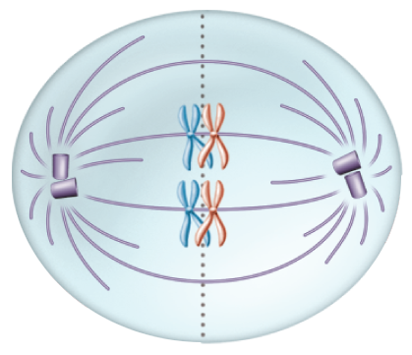

1. Which of the following phases of Meiosis is represented by the diagram on the right?
2. **Prophase II**
3. **Metaphase II**
4. **Metaphase I**
5. **Telophase I**

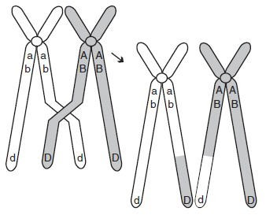

1. The diagram on the right shows homologous chromosomes during prophase I of meiosis. Which of the following correctly describes the process being illustrated?
2. **mutation in which the DNA content of the gene is altered**
3. **segregation of sister chromatids**
4. **condensation and segregation of alleles**
5. **crossing-over in which alleles are exchanged**
6. Why is crossing over an important step during meiosis?
   1. It ensures that chromosomes are lined up correctly during metaphase I.
   2. It provides genetic variation in the sex cells.
   3. It allows the entire chromosome to switch places with its sister chromatid.
   4. It ensures that all cells are genetically identical to the original cell.
7. Meiotic cell division results in gametes (sperm and egg cells) by:
8. Reducing the daughter chromosome number in half (by 50%)
9. Reducing the daughter chromosome number by one-third (1/3)
10. Increasing the daughter chromosome number in half (by 50%)
11. Increasing the daughter chromosome number by one-third (1/3)
12. Which of the following is TRUE about Meiosis?
13. Only 1 division occurs during the entire process
14. Sex cells are formed during the process
15. Crossing over does NOT occur
16. 1 new cell is formed
17. Which of the following is a true characteristic of homologous chromosomes?
    1. They carry genes for the same trait on them.
    2. They pair up during Prophase 1 of Meiosis I.
    3. One comes from the mother and one comes from the father.
    4. All of the above statements are characteristic of homologous chromosomes.
18. Identify the heterozygous dominant genotype example below
    1. BB
    2. Bb
    3. bb
    4. None of the above