Macromolecule Quiz I Name: ___________________________
Some words may not be used and some can be used more than once November 7, 2016
Nucleotide | Amino Acid | Disaccharide | Red | Black
Carbon | Nitrogen | Oxygen | Monosaccharide | Burnt Orange
Energy | DNA | 1:2:1 | 2:3:1 | Carbohydrate
Protein | Lipid | Nucleic Acid | Triglyceride | Structural Support
Starch | Sugar | Saltine Cracker | Blue | Purple

- __________________________ All living things are mostly made of this element
- __________________________ This macromolecule stores and transmits genetic information
- __________________________ The building blocks of Nucleic Acids
- __________________________ The building blocks of Proteins
- __________________________ The building blocks of Carbohydrates
- __________________________ The building blocks of Lipids
- __________________________ Carbohydrates primarily function to give our body
- __________________________ Proteins primarily function to give our body
- __________________________ A positive color for simple carbohydrates (sugar) is
- __________________________ A positive color test for complex carbohydrates (starch) is
- __________________________ A positive color test for proteins is
- __________________________ What macromolecule is Lugol’s Iodine test used to detect
- __________________________ What macromolecule is Benedict test used to detect
- __________________________ What macromolecule is Biuret test used to detect
- __________________________ What ratio exemplifies a carbohydrate?
Write the name of the macromolecule whose chemical structure is shown below?
Carbohydrate Lipid Protein Nucleic Acid
- __________________________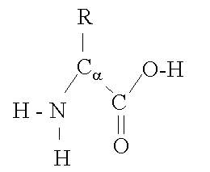

- __________________________ 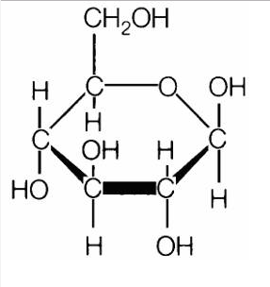

- __________________________ 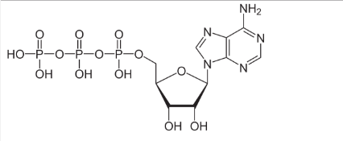

- __________________________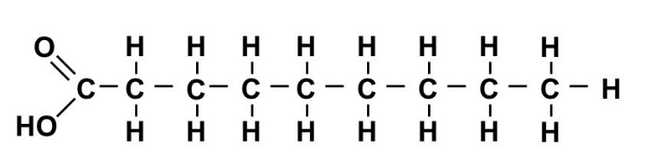

- __________________________ Hair and nails are an example of this macromolecule

