Investigating Cellular Respiration and Fermentation

Laboratory Objectives:
- Define Cellular Respiration, ATP, Aerobic/Anaerobic Respiration
- List and describe starting materials and end products of cellular respiration (aerobic and fermentation) including number of ATP molecules and all by-products
- Describe cellular location of aerobic and anaerobic respiration
- Interpret the results of the experiment and explain why or why it didn’t work for your lab.

Introduction:

Cellular Respiration

All organisms must have the ability to extract energy from the environment in which they live in order to power cellular processes. We are able to extract energy from the food we consume by a process known as cellular respiration. Compare this process to your TV at home. A TV cannot take energy directly from coal or oil. These fuels first must be converted to electricity in the power plant before they can be used by the TV.

In the process of cellular respiration, cells extract the energy stored in food molecules (such as carbohydrates, fats, and proteins) and transfer it into ATP (adenosine triphosphate), which is the universal energy source used by cells to run cellular activities, also known as, “the currency of the cell.” The first step of the cellular respiration begins with glycolysis and energy-rich compound, glucose, serves as the initial substrate of respiration. During the cellular respiration, glucose is transformed into the energy-poor molecules, carbon dioxide (CO2) and water (H2O), while the energy is extracted and transferred to ATP:
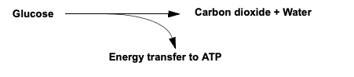

Cellular respiration can actually proceed in three general directions, depending upon the availability of oxygen O2 and the ability of organism involved: aerobic respiration, alcoholic fermentation and lactic acid fermentation (see Figure 7.1)
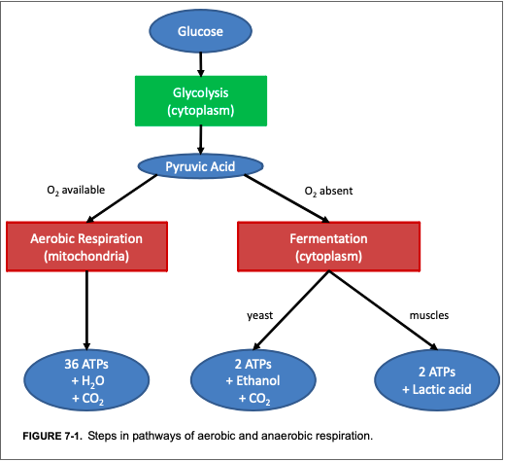

Cellular Respiration Steps
The first major step in cellular respiration is glycolysis (see Figure 7.2 on next page);

What happens next depends on whether or not oxygen is available to the cells. When oxygen is available, cells will transport pyruvic acid into the mitochondria to undergo both the Krebs cycle and the electron transport chain to make up to 36 ATPs b (see the right side of the Figure 7.2 on next page)

Cellular respiration that uses oxygen is called aerobic respiration. Most of the time our cells in our bodies use aerobic respiration.
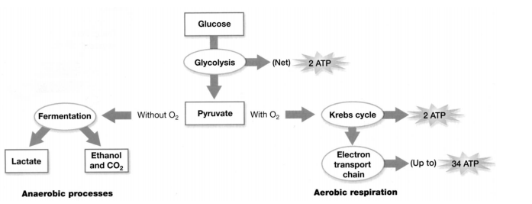
Figure 7.2: Cellular Respiration

When oxygen is not available, cells use anaerobic processes to produce ATP. (The "an" in front of aerobic means "not aerobic".) Under anaerobic conditions, many cells use a process called fermentation to make ATP.

As shown in the figure above, there are two types of fermentation: lactate fermentation (e.g. in muscles when an animal exercises hard) and alcoholic fermentation (e.g. by yeast to make wine and beer).
Fermentation has two disadvantages compared to aerobic respiration. Fermentation produces much less ATP than aerobic respiration, and fermentation produces a toxic byproduct (either lactate, which becomes lactic acid, or alcohol). However, fermentation is very useful if oxygen is not available.

Anaerobic Respiration Using Yeast
Yeast is a unicellular fungus that can thrive on the low energy yield of fermentation in the absence of oxygen. Yeast ferments a glucose molecule to yield energy (2 ATP’s). During the process, ethyl alcohol and carbon dioxide are also produced as byproducts.

Yeast fermentation is used commercially in the production of alcoholic beverages and bakery products utilizing these byproducts. A monosaccharide fructose is also used by yeasts as fermentation substrate. Also, sucrose is a good substrate for yeast fermentation. Sucrose is broken down by a yeast enzyme, the invertase, into glucose and fructose, which are native substrate of yeast fermentation.

If you want to make your own bread, you can buy yeast in the grocery store. This yeast consists of little brown grains. The little brown grains of yeast may not seem to be alive, but if you put them in water with sugar, the yeast will carry out cellular respiration and grow.

You can grow yeast in a test tube filled with water and sealed with a balloon. Do you think these growth conditions are aerobic or anaerobic?

Under anaerobic conditions, yeast carries out alcoholic fermentation, so it produces _________________ and ____________________. You can measure the rate of fermentation in yeast by measuring the amount of carbon dioxide gas the yeast produces. Carbon dioxide production can be measured by measuring the depth of the layer of bubbles trapped in foam on top of the yeast solution and also by observing the balloons, which catch the carbon dioxide produced and get bigger.

Experiment 1: Detection of Cellular Respiration

Yeast is a unicellular fungus that perform aerobic respiration using similar pathways to those found in higher plants and animals. Methylene blue dye can be used as an indicator in a simple check to determine where cellular respiration has occurred in yeast.
Aerobic respiration releases hydrogen ions (H+) and electrons (e- ) which are picked up by the methylene blue gradually turning it colorless. Thus, if cellular respiration is occurring in the mitochondria of yeast cells, the mitochondria will appear as a clear area surrounded by a ring of light blue cytoplasm. The nucleus may be visible as a small stained spot.
If cellular respiration is not taking place, the mitochondria will absorb the methylene blue dye and thus will not be colorless. The cells will appear to have a large, darkly stained central area surrounded by the ring of light blue cytoplasm.

NOTE: The following procedure will be performed by your lab instructor and the results will be presented for your review.

- Place a drop of yeast suspension on a clean microscope slide. Add one small drop of
methylene blue and place a cover slip over the mixture.
2. Observe the yeast cells using the high-power objective and answer the following questions
on page x of your lab manual:

- How can you tell if the yeast is undergoing cellular respiration or not using the indicator methylene blue?
- What estimated percentage of yeast cells are undergoing cellular respiration that you observed?
- Why isn’t cellular respiration occurring in all cells?

Experiment 2: Sucrose Concentration

What is sucrose? Sucrose is a disaccharide comprised of glucose and fructose (two different sugar molecules) bound together to form a compound more commonly known as table sugar.
Your first experiment will investigate the effect of sucrose concentration on the rate of cellular respiration in yeast. Yeast can convert sucrose into glucose and use it during cellular respiration. You will design an experiment to answer the given fundamental question: Does the concentration of sucrose affect the rate of cellular respiration in yeast?

Your teacher will provide you with yeast, test tubes, balloons, rulers, and four concentrations of sucrose water: 0% (plain water), 1%, 5% and 10% sucrose.

Setting up the Experimental Design

Before you begin setting up the experiment, answer the following questions on page x of this lab manual. Make sure all group members agree on all questions before moving onto setting up the experiment.

- Write a hypothesis that you will test to help you answer the research question.
- What will be the independent variable in your experiment?
- What will be the dependent variable in your experiment?
- What will be the control treatment in your experiment?
- What is the purpose of this control treatment?

Methods
The basic procedure to measure cellular respiration is:
1.Grab 4 clean test tubes and label them 0%, 1%, 5%, 10% respectively and add 25 mL of the appropriate sucrose solution to each tube.
2. Add ¼ tsp of yeast to each tube and quickly place a balloon on the top of each tube before setting it in test tube rack.
3. With your palm or thumb sealing the top, shake each tube until the yeast is dissolved.
4. Measure the depth of bubbles produced and observe how the balloons change after 10 minutes and 20 minutes.
5. Record depth of CO₂ in mm and circumference of balloon in cm in table provided.
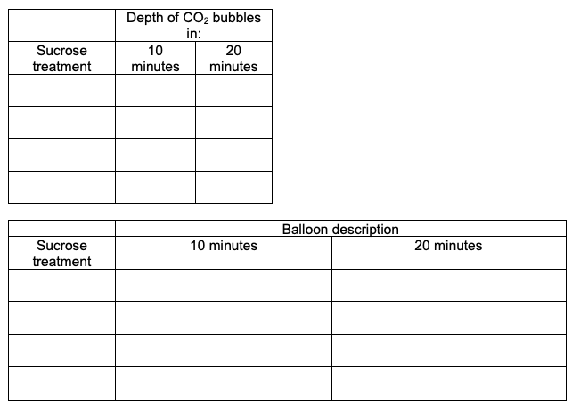
Data

Analyze the data and answer the following questions on page x of your lab manual.
Cellular Respiration Lab Questions Name: ________________________

Introduction:
- What is the first step of the cellular respiration? What is the starting material?

- Where in the cell does glycolysis occurs?__________________________

- Where in the cell does aerobic respiration occurs? _______________________________

- Where in the cell does fermentation occurs? ____________________________________

- What are the products of the anaerobic respiration?

- What are the products of the alcoholic fermentation?

- What are the products of the lactic acid fermentation?

- Which produces the greatest amount of ATP, aerobic respiration or fermentation?

- How many ATPs are produced via aerobic respiration? How many by anaerobic respiration?

Experiment 1:
- How can you tell if the yeast is undergoing cellular respiration or not using the indicator methylene blue?

- What estimated percentage of yeast cells are undergoing cellular respiration that you observed?

- Why isn’t cellular respiration occurring in all cells?

Experiment 2:

- Write a hypothesis that you will test to help you answer the given fundamental question.

- What will be the independent variable in your experiment?

- What will be the dependent variable in your experiment?

- What will be the control treatment in your experiment?

- What is the purpose of this control treatment?

- Did the yeast produce different amounts of carbon dioxide with different sucrose concentrations?

- Was your hypothesis rejected or failed to be rejected based off your results? Use at least one specific example from your results to justify your answer.

- What conclusions concerning the relationship between sucrose concentration and the rate of cellular respiration are supported by your results?

