Ecology

Ecology:
List some limiting factors that would affect a plant (such as a corn plant) population.
- Light, carbon dioxide concentration, temperature, nutrients in soil, water
List some limiting factors that affect an animal such as a field mouse
- Food source, oxygen, temperature, mates available, predators preying on mice
Which organisms need nitrogen? What is nitrogen needed for?
- ALL organisms need N₂, it is used for making proteins and other biomolecules
How can nitrogen be returned to soil? What is this process called?
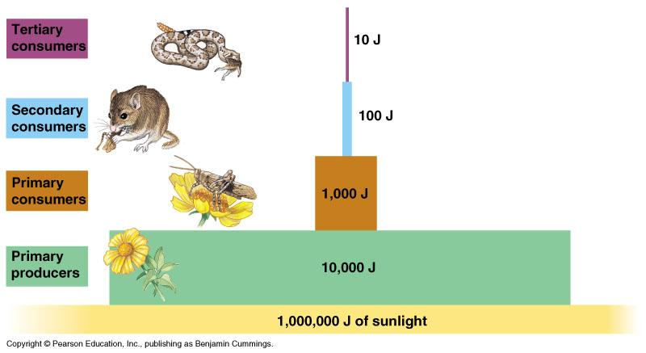
- Bacteria convert N₂ in air to Nitrate (NO₃⁻) for plants; called nitrogen fixation- a major role; N₂ can also be returned to soil from urine, feces and chemical fertilizers.
What is mutualism? List an example of this symbiotic relationship.
- Mutualism – a relationship in which two organisms interact and both benefit. Example: a flower and a butterfly – flowers provide food, butterfly pollinates the flower
What is parasitism? List an example of this symbiotic relationship.
- Parasitism – when one organism lives on or in another and obtains part or all of its nutritional needs from its host Example: Tics feed on animals, can transmit disease to host.
What is commensalism? List an example of this symbiotic relationship.
- Commensalism – a relationship in which one species benefits nd one is not helped or harmed. Example: Cattle egrets (birds) are found in fields where cows/horses move through grass feeding, making insects move up out of the grass, and the egret then eats insects- benefits. No benefit or harm for cows.
How can grass (a ground cover) protect soil?
- The roots on grass spread out and hold the topsoil in place.
What happens to the total energy available from one trophic level to the next? Why?
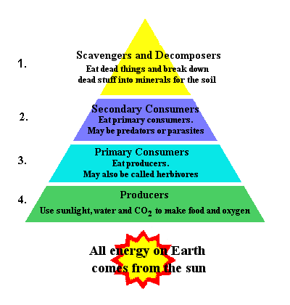
- The energy level decreases from one trophic level to the next. The organism in the lower trophic level uses some of the energy it received (for metabolic activities) and releases the rest as heat. (*Remember that is why there are many more organisms at the lowest level- producer, fewer at the primary consumer (herbivore) and much less at the secondary consumer (carnivore).
How are animal populations affected by volcanic activity? What type of
succession is shown by volcanic activity? How do you know?
- Animals move out or are killed during volcano so the populations decrease. Volcanoes are an example of primary succession; the lava flows form rock. Over time, the rock will be broken into soil, then plant and animal life returns.
What type of succession follows a forest fire? What is a benefit to forests after
a fire?
- Forest fires are an example of secondary succession (soil remains- not rock). Plants (trees) are burned, which return nutrients to the soil. Some pine trees only have their cones open and release their seeds after the high heat a forest fire.
What happens to the animal population after a forest fire?
- After a forest fire, the animal population decreases immediately. Animals move out of the area or are “caught” in the fire.
After damage to an ecosystem (fire, volcanoes, floods, etc); how does the
damaged ecosystem begin restoration?
- After fire – pine trees release their seeds into the “newly amended” soil and forest begin to grow again. After volcanoes, lichens grow on the rock, breaking down into soils, then plants grow.

If a lake is covered by an overgrowth of algae, what could be the effects on the living organism (biotic factors)? What could be
effects on the abiotic (nonliving factors)?
- Biotic factors: that result due to an overgrowth of algae (which is a producer) is that there would be an increase of herbivorous fish, then more carnivorous fish. Abiotic factors: affected are there would be an increase of oxygen (more photosynthesis), and the water temperature would decrease due the inability of light penetrating the surface of the water (to warm it).
In a food web or an ecological pyramid, which organism is on the first level?
- Producers (photoautotroph or chemoautotroph) are always on the first level. It is at the bottom of a pyramid (largest base) so that it can support the rest of the food web. In a food web, at which level are carnivores found? Carnivores are found on the secondary consumer (3rd trophic level), tertiary or quaternary consumer (4th/5th trophic level). In the food web, carnivores only consume other heterotrophs. * Remember carnivores are the predator, so there are fewer of them. There has to be more prey to sustain their population. The populations of both are “kept in check”.
In a food web, organisms that feed on other organisms are called?
- Heterotrophs or consumers
Detritovores which feed on dead animals, such as a vulture, can also be called a?
- Scavenger
Organisms that use energy (from light or chemical compounds) are called?
- Autotrophs or producers
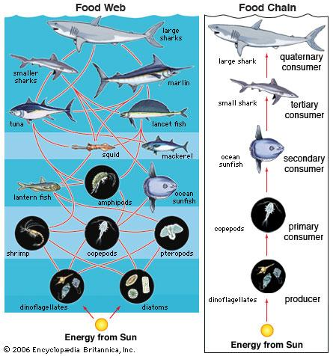
How have plants that live in poor soil conditions managed to be
successful?
- The soil in these areas produces thick growth due to the rapid rate of nutrient recycling from dead tree logs, leaves, etc. The rate of decomposition partly accelerated to the warm, wet areas.
With the increasing number of humans, what affect does this have
on the natural resources?
- As the human population increases, the natural resources available decreases.
What is a predator? List an example. Why are predators important
in a food web?
- Predators are animals that eat other animals.
Examples include wolves and hawks. One function of a predator is that they maintain the number of prey (which for the most part are herbivores). If the predator moves out or dies, the prey population increases, eating the plant population.
What is a prey? List an example. Why are prey important in a food
web?
- Prey are animals that tend to be herbivores. Examples are mice and deer. Prey provide food, which is a source of energy for predators.
What is the role of fungi (such as mushrooms, bracket fungi) &
lichens (algae & fungus) to an ecosystem?
- Fungi and lichens are decomposers. They break down complex compounds into smaller ones that can be absorbed by other organisms.
What specifically do lichens that live on rocks do for an ecosystem?
- Lichens play a very important role – they break down rocks into soil, so that plants and other organisms can move into the ecosystem.

Practice Questions:
1. Celia steps off the sidewalk without looking into the street, and narrowly misses being hit by a car. Her heart beats faster, her
breathing becomes more rapid, her skin gets cold and clammy, and she begins to tremble. Which of the following triggers this fight-or
flight response in Celia?
Examples of Physical Fight-or-Flight Responses
Muscles tense
Blood pressure increases
Digestion slows or stops entirely
Breathing and heart rates increase
Pupils dilate

a. the shutdown of the active transport system which moves ions into and out of the cells
b. the failure of neurons to conduct impulses quickly enough
c. the release of hormones and the activation of the sympathetic nervous system
d. fluid movement in the cochlea resulting in bending of hair cells

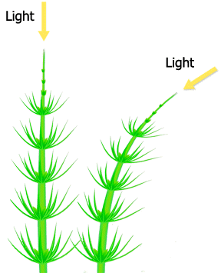
2. Plants grow and position their roots, stems, and leaves in response to a variety of
environmental stimuli. These responses are called tropisms. Which of these refers to the
growth response of a plant towards light?

a. gravitropism
b. thigmotropism
c. nastic movement
d. phototropism

Nitrogen (N) is used and reused by various organisms and processes as it cycles through the environment.

3. Study the statement above. Which of the following statements about the nitrogen cycle is false?
a. Plants use nitrogen to make proteins and other molecules.
b. Nitrogen-fixing bacteria play a minor role in the nitrogen cycle.
c. Urine from animals returns nitrogen to the soil.
d. Decomposers release nitrogen compounds into the soil.

Forest fires change ecosystems in many ways. Some changes are immediately apparent, white others are not.

4. Refer to the information above. How are animal populations affected by fires?
a. Animal populations increase immediately after a fire.
b. Animal populations decrease immediately after a fire.
c. Animal populations are not affected by forest fires.
d. Animal populations show a dramatic increase, then decrease immediately after a fire.

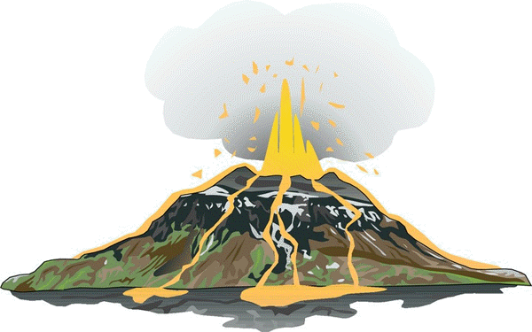
Lava flowing from an erupting volcano destroys everything in its path. New land is formed, but it is barren, supporting no organisms.

5. Refer to the information above. How are animal populations affected by volcanic activity?
a. Animal populations decrease after volcanic activity, but reestablish over time.
b. Animals never return to an area affect by volcanic activity.
c. Animal populations are not affected by volcanic activity.
d. Animal populations are only slightly affected by volcanic activity.

Organisms within food webs are interdependent and often compete for resources.

6. Read the statement given above. Organisms that use light energy stored in chemical compounds to make energy-rich compounds
are known as-
a. heterotrophs b. autotrophs c. scavengers d. decomposers

7. The coyote feeds on jackrabbits, which feed on plants.
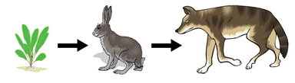

Which of these best describes the jackrabbit in this desert community food web?
a. The jackrabbit is an autotroph.
b. The jackrabbit is a producer.
c. The jackrabbit is prey for the coyote.
d. The jackrabbit is a carnivore.

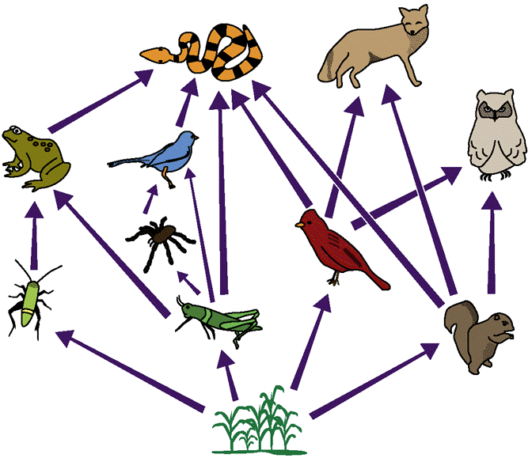
8. The diagram below shows a food web made up of a variety of organisms involved in

different feeding relationships. Which term best describes the role of crickets in the food
web shown?

a. Crickets are predators of frogs.
b. Crickets are prey for spiders and snakes.
c. Crickets are a second-order consumer of spiders.
d. Crickets are producers of energy.
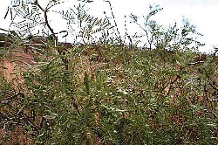
9. The pods from honey mesquite trees are a food source for beetles.

Which of these best describes the honey mesquite trees in this desert community food web?
a. The honey mesquite tree is an omnivore.
b. The honey mesquite tree is a predator of beetles.
c. The honey mesquite tree is a consumer.
d. The honey mesquite tree is a producer.

10. The desert tortoise feeds on prickly pear cactus and other plants.
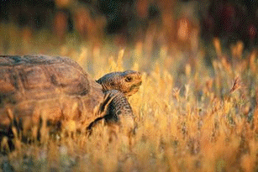

Which of these best describes the desert tortoise in this desert community food web?
a. The desert tortoise is an herbivore. c. The desert tortoise is a predator.
b. The desert tortoise is a producer. d. The desert tortoise is a carnivore.

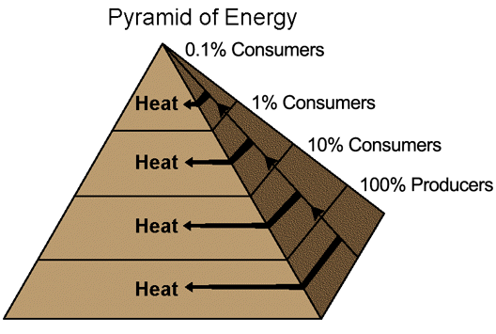
11. The diagram shows a pyramid of energy, with producers at the bottom and higher
order consumers occupying successively higher levels. As energy is transferred from
producers to first-order, second-order, and higher-order consumers, a large amount of
energy is converted to thermal energy and given off as heat. Which statement is true?
a. More useful energy is available to higher-order consumers than to first-order consumers.
b. The amount of useful energy is no different at different levels of the pyramid.
c. The amount of useful energy increases at each successively higher level in the pyramid.
d. Less useful energy is available to higher-order consumers than to first-order consumers.

12. The prickly-pear cactus shown in the figure above has a leaf adaptation that
a. pumps out salt c. produces thick, green stems
b. reduces water loss d. produces seeds when it rains

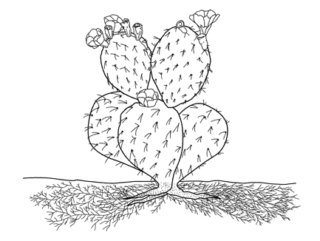
13. How is the cactus in the figure above adapted to soak up rare rainfall quickly?
a. It has thin, sharp spines.
b. It has stems that shrivel when it rains.
c. It has wide stems that catch rainwater.
d. It has an extensive shallow root system.

14. How is the cactus in the figure above adapted to survive long dry periods?
a. Its stems swell and store water.
b. It leaves drop off when it gets dry.
c. Its root system holds water for later use.
d. It remains dormant when there is no rain.

15. The crab Lybia tessellate carries a pair of sea anemones on its claws. The crab uses the sea anemone’s stinging tentacles as protection and the sea anemone obtains small food particles released by the crab as it feeds. Which type of symbiotic relationship does this best illustrate?
a. commensalism b. mutualism c. parasitism d. predation

16. What is the main difference between primary succession and secondary succession?
a. Primary succession happens slowly, and secondary succession happens rapidly.
b. Small plants grow first during primary succession, while large trees grow first during secondary succession.
c. Primary succession occurs after a natural disaster, and secondary succession occurs before a natural disaster.
d. Primary succession is the colonization of new sites, and secondary succession is colonization of previously inhabited sites.

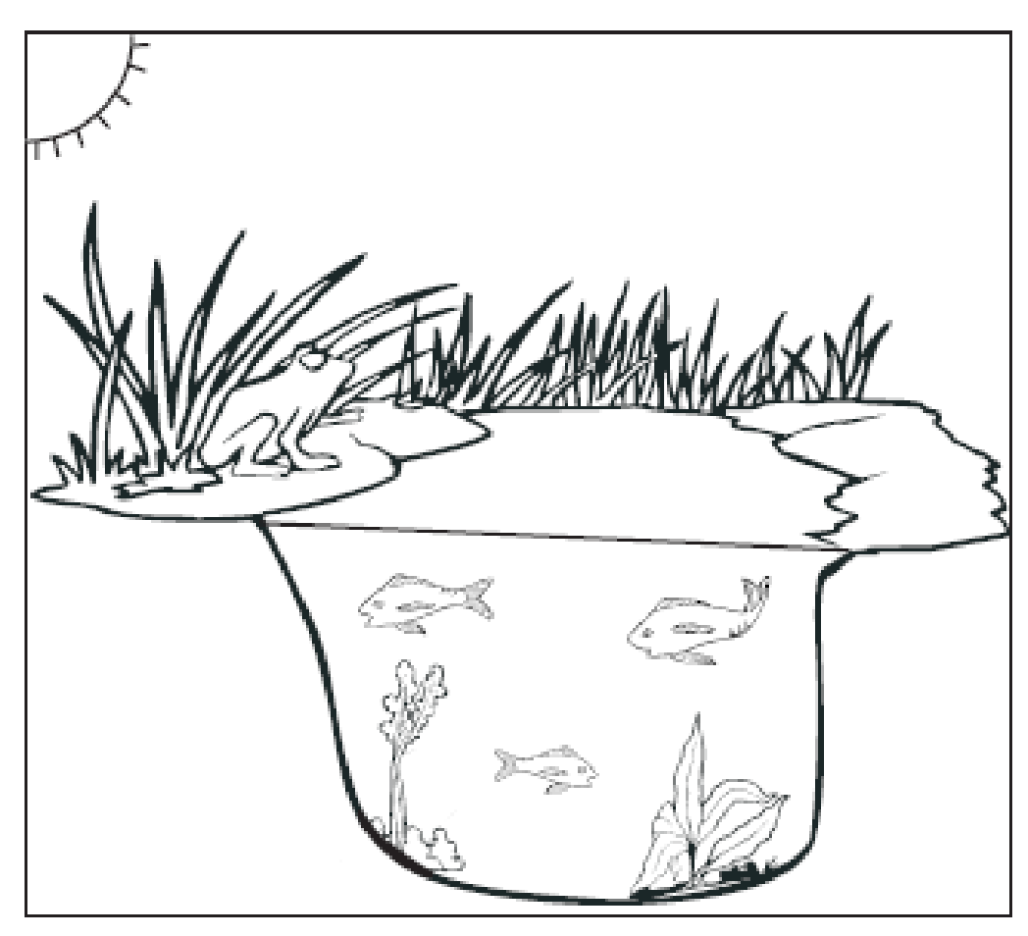
17. An example of a biotic factor in the ecosystem shown to the right is

a. the Sun
b. the soil
c. the water
d. the plants

18. The symbiotic relationship between a tick and the dog it is biting is called
a. predation b. parasitism c. mutualism d. commensalism

19. A person sweating on a hot day would most likely be an example of what biological process?
a. digestion b. respiration c. homeostasis d. gametogenesis

20. Why do leaves tend to be flat?
a. so that water can easily be absorbed and carried to the rest of the plant
b. so that sunlight can easily penetrate to the leaf’s photosynthetic tissues
c. so that nutrients can easily enter the plant and be used for structure and support.
d. so that plants can easily find balance due to the symmetrical nature of their branches

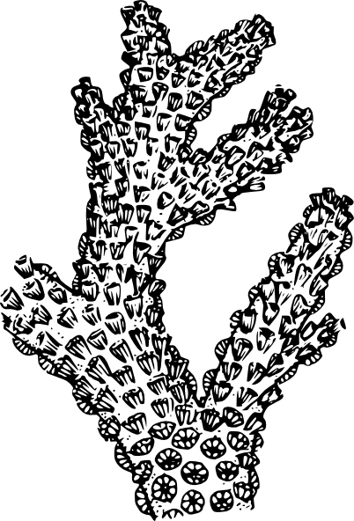
21. Which figure shows an organism with radial symmetry?
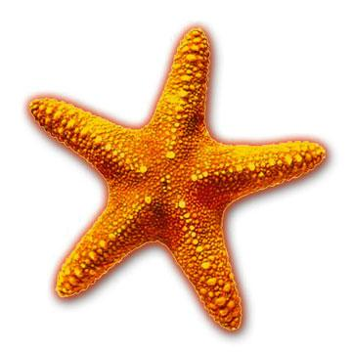
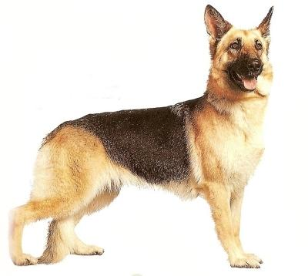
a. b. c. d.

22. Moss often grows on trees. The tree is not affected, while the moss has the nutrients it needs to grow. What type of symbiotic
relationship is this?
a. predatory b. parasitism c. mutualism d. commensalism

23. Which best describes the interaction between autotrophs and heterotrophs?
a. One competes with the other for access to sunlight and soil.
b. One decomposes the other to release nutrients back into the soil.
c. One helps produce the other in a mutually beneficial relationship.
d. One consumes the other to use energy that originally came from the sun.

24. The diagram to the below of an aquatic ecosystem represents what elemental cycle on Earth?

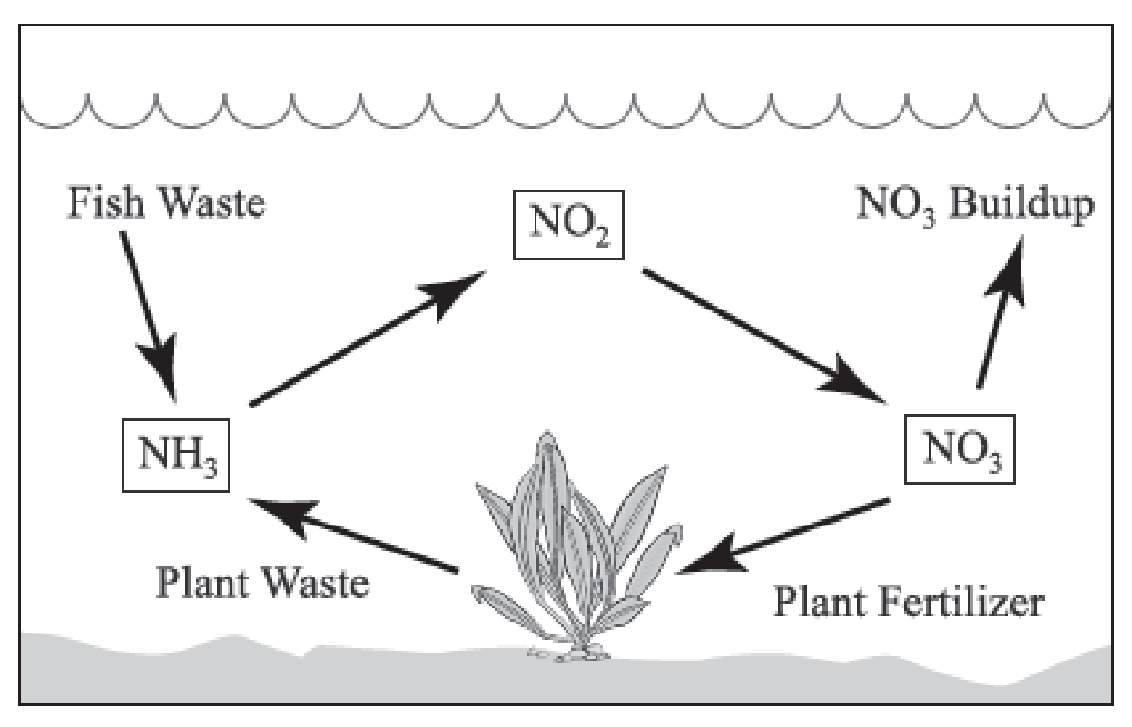

a. water
b. carbon
c. nitrogen
d. phosphorus

25. The figure below shows the number of plants and animals necessary to support life of one high-level consumer in a temperature
grassland biome.

The figure represents the flow of energy through-
a. different trophic levels in most ecosystems
b. soil, plants, and animals during the nitrogen cycle
c. different organisms within a single level of most food webs
d. the atmosphere, land, and bodies of water during the water cycle

26. Which organism in the aquatic food web to the right gets energy directly from the Sun?
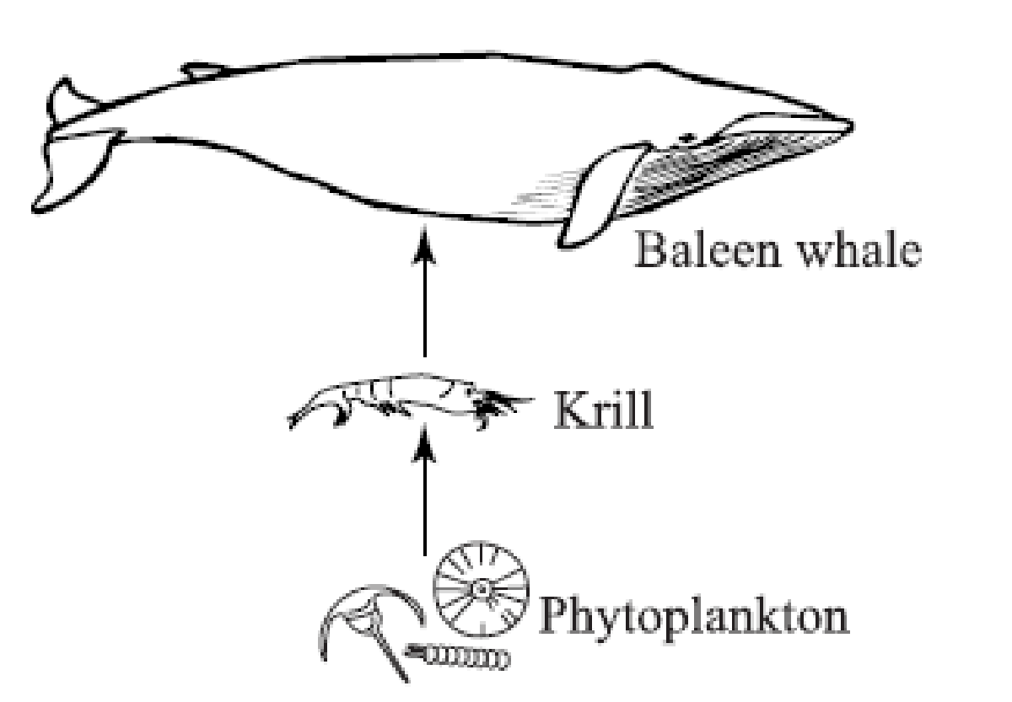

a. krill
b. baleen whale
c. phytoplankton
d. both krill and the baleen whale

27. Which two systems work together to make sure that oxygen reaches the blood stream and carbon dioxide is removed from the
bloodstream?
a. digestive and circulatory
b. circulatory and excretory
c. respiratory and circulatory
d. respiratory and endocrine

