The Effect of pH and Temperature on Peroxidase Found in Beef Liver
By
Jillian Johnson
Cynthia Cervantes
Daniella Walton

September 21, 2015

Alex Aitken
Biology II
Fall 2015

Abstract
In the reaction between peroxidase and hydrogen peroxide, hydrogen peroxide is broken down to become water and oxygen. The purpose of the experiment tested was to see if there was peroxidase in the substrate, and to identify the rate at which it reacted in various temperatures and pHs. Without an enzyme, the reactants used a high amount of activation energy. When an enzyme was involved, much less activation energy is used when making the same amount of product as without an enzyme.
Introduction
Enzymes speed up chemical reactions by lowering the activation energy. All known enzymes are proteins which are principally composed of chains of amino acids linked together by peptide bonds. They are also a biological catalyst. A catalyst being a substance that increases the rate of a chemical reaction without itself undergoing any permanent chemical change.
Activation energy describes the minimum amount of energy which must be available to a chemical system with potential reactants to result in a chemical reaction. This can be shown as: 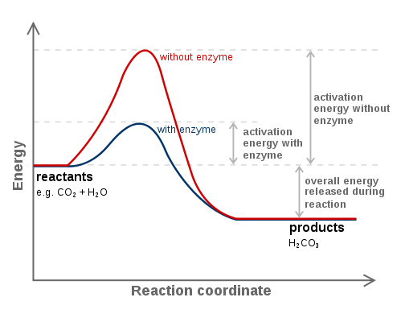An ES-Complex, otherwise known as the enzyme substrate complex, is an intermediate substance formed from the enzyme and the substrate. The reaction can be represented as: 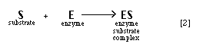
Some factors that affect enzymes are, but not limited to, correct environmental conditions, proper substrates, and, often, particular cofactors associated with an enzyme. With saying that, there are specific, optimal conditions for an enzyme which can be deduced by the organism from which the enzyme is derived, the part of the organism in which the enzyme functions, and the environmental conditions in which that organism lives.
For this experiment, the enzyme and acting catalyst used was peroxidase, which in this case is found in liver. Two molecules of hydrogen peroxide, which is harmful to cells, are broken down into two molecules of water and a molecule of oxygen gas. This can be represented by: 2H₂O_{22H2}O + O₂(g) The presence of peroxidase allows the cells to break down hydrogen peroxide fast enough so that the cells do not become tainted. This reaction occurs within two seconds to contact of peroxidase and hydrogen peroxide. Therefore, if hydrogen peroxide comes in contact with the enzyme peroxidase, then the hydrogen peroxide will be broken down into two part water, one part oxygen.
Methods
Experiment 1: The Effect of Temperature on Catalase Activity
I put a piece of liver into the bottom of a clean test tube and covered it with a small amount of water. I then placed this test tube in a boiling water bath. After 5 minutes, I removed the test tube from the boiling water bath, allowed it to air cool and then poured the water out. After that, I pipeted 2 milliliters of hydrogen peroxide into the test tube, allowing it to react with the now boiled liver.
I then put equal quantities of liver into 2 clean test tubes, and 1 milliliter of hydrogen peroxide into 2 other test tubes. I put one of the test tubes of liver and one of the test tubes of hydrogen peroxide into an ice bath. The other set of liver and hydrogen peroxide was placed into a warm, room temperature, water bath. After 3 minutes, I poured each tube of hydrogen peroxide into the corresponding test tube of liver and observed the reaction.
Experiment 2: The Effect of pH on Catalase Activity
In 6 test tubes, I placed 2 milliliters of hydrogen peroxide to each of 5 clean test tubes. The following substances were added into their specific containers: Test Tube 1: 4 drops of acetic acid, Test Tube 3: 4 drops of sodium bicarbonate, Test Tube 4: 4 drops of lemon juice, Test Tube 5: 4 drops of bleach, and Test Tube 6: 3 drops of water. I added liver to each of the test tubes and quantitated their rates of reaction.
Results

The reaction rate for the boiled liver and peroxide was quantitated as a one . The rate for cold liver/peroxide was 2, where the rate for the warm liver/peroxide was a three (as shown in Table 1).
Table 1
Table 1 | Boiling | Room Temperature | Cold
5
4
3
2
1

*These results were quantitated on a scale of 1 – 5, 1 being the least reactive and 5 being the most reactive.

After adding the various substances to hydrogen peroxide, I determined the pH of the solutions. Acetic acid went to 4.2, sodium bicarbonate to 7.2, lemon juice to 4, bleach to 9, and water to 4.5
With the addition of liver to the solutions, I quantitated these reactions. Vinegar being 3, NaOH being 4, lemon juice being 1, bleach being 1, and water being 5.
In general, the category with the optimal enzymatic range for peroxidase to work was of neutral.

Table 2 | Effect of pH
Substrate | Reaction Rate
Vinegar | 3
NaOH | 4
Lemon Juice | 1
Bleach | 1
Water | 5
*These results were quantitated on a scale of 1 – 5, 1 being the least reactive and5 being the most reactive.
Discussion
Bubbles occurred in NaOH, but not HCL because the NaOH had a more neutral pH when added with hydrogen peroxide. This means that the optimal pH range for peroxidase to react is in a neutral range. The pH affects the enzymatic rate because it not only changes the shape of an enzyme, but also the charge properties of the substrate so that either the substrate cannot undergo catalysis or it cannot bind to the active site.
Temperature also affects the rate of reaction. As the temperature increases, so does the rate of reaction because it speeds up the activity. Despite this, there is a point where the temperature can become too high and it begins to denature the enzymes.
Based on what I knew about enzymes, I did not expect the reactions to go the way that they did. I was surprised that as the pH got more neutral, the higher the reaction rate became. I had predicted that the higher the pH, the higher the rate. I also hypothesized that the higher the temperature, the higher the reaction rate. This was confirmed by the data in which the reaction taking place in the boiling water had a faster rate of reaction when compared to the room temperature water and the cold water.
My original hypothesis that if hydrogen peroxide comes in contact with the enzyme peroxidase, then the hydrogen peroxide will be broken down into two part water, one part oxygen was confirmed by the data and failed to be rejected.
Some possible sources of error could be in the way the relative reaction rate was quantitated. For future experiments, I would take a ruler to the bubbles formed and measure it in centimeters, and have that measurement be the system instead. To test the pH, I could have used pH paper to detect the exact value. For temperature, I could have had a thermometer in various temperatures of water and rate the reactions based on that.
Literature Cited
Brooklyn College | Home. (n.d.). Retrieved September 22, 2015.
Chemguide: Helping you to understand Chemistry - Main Menu. (n.d.). Retrieved September 22, 2015.
Enzymes, Biochemicals: Worthington Biochemical Corporation. (n.d.). Retrieved September 22, 2015.

