Formative Assessment
Central Dogma

- Where do genes come from?
DNA
- What are the steps of the Central Dogma of Biology
Central Dogma is the process of going from DNA to RNA to proteins.
Step 1. Transcription
Step 2. Translation

- What happens during transcription?
During Transcription, RNA Polymerase II binds to an opened portion of the genome and copies (transcribes) the complimentary portion of the DNA into mRNA

- Draw the maturation of mRNA.
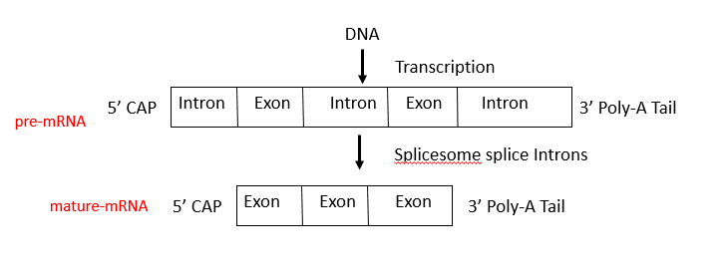
- What happens during translation?
mRNA leaves nuclear pore and finds a ribosome. The ribosome then reads the genetic code in blocks of three called a codon. In the “A” site of the ribosome, a complimentary stretch of genetic code (called an anti-codon) is carried to the ribosome by tRNA. The tRNA is carrying a specific amino acid and releases its amino acid in the “P” site of the ribosome. This site is where the polypeptide chain is made before the tRNA leaves via the “E” site of the ribosome and searches for another specific amino acid.

- A house mouse, Mus musculus¸ has a genome comprised of 15% guanines. Tell me how many cytosine, adenine, and thymine would be expected.

Cytosine = 15% Thymine = 35%
Adenine = 35%

- How many types of RNA are present in the body and what are the function of each.

rRNA- what ribosomes are made of
tRNA- carry amino acid to ribose
mRNA- copy of ONE protein recipe

