Name _________________ Section ______
Aitken’s Biology Class Date _______________

mRNA Codons
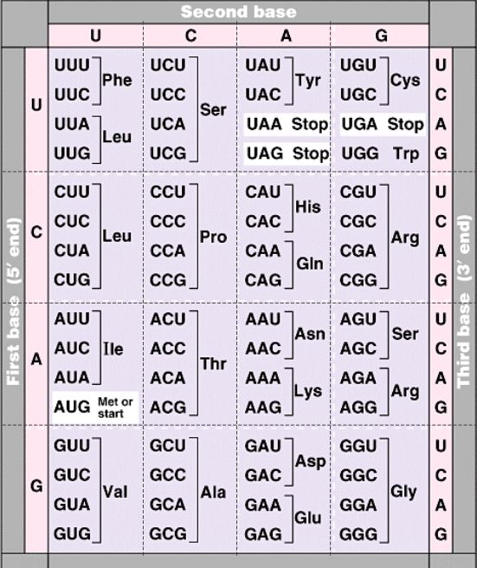

Name _________________ Section ______
Aitken’s Biology Class Date _______________

Amino Acid Codes
