Cell Quiz III Name: ____________________________ January 26, 2017
- Which of the following encloses their DNA in a nucleus?
A. | prokaryotes
B. | bacteria
C. | eukaryotes
D. | viruses

- Which of the following organisms are prokaryotes?
- Plants
- Animals
- Fungi
- Bacteria

- Which of the following is a function of the nucleus?
- Stores DNA
- Stores sugar
- Builds proteins
- Packages proteins

- Which of the following best describes the relationship between the nucleus and the cytoplasm?
- The cytoplasm is a fluid that fills the inside of the nucleus
- The cytoplasm is an organelle that is usually found near the nucleus.
- The nucleus is an organelle that is surrounded by the cytoplasm.
- The nucleus is a fluid and it mixes with the fluid cytoplasm.

- Which of the following is a function of the cytoskeleton?
- Helps a cell keep its shape
- Contains DNA
- Surrounds the cell
- Helps make proteins

- Which organelle converts the chemical energy stored in food into compounds that are more convenient for the cell to use?
- Chloroplast
- Golgi complex
- Endoplasmic reticulum
- Mitochondria

- Which of the following is a function of the cell membrane?
- Breaks down lipids, carbohydrates, and proteins from foods
- Stores water, salt, proteins, and carbohydrates
- Keeps the cell wall in place
- Regulates the movement of materials into and out of the cell
- The cell membrane contains channels and pumps that help move materials from one side to the other. What are these channels and pumps made of?
- Carbs
- Lipids
- Bi-lipids
- Proteins
- Nucleic Acids

- Which organelle contains enzymes that are necessary for intracellular digestion? (1pt)
- Flagella
- Lysosome
- Mitochondria
- Ribosome

- While lifting weights, muscle cells consume large amounts of energy. Which organelles increase their activity in muscle cells during weight training to make more energy available? (1pt)
- Nucleus
- Ribosome
- Mitochondria
- Golgi bodies

Use the diagram below to answer questions 11-14
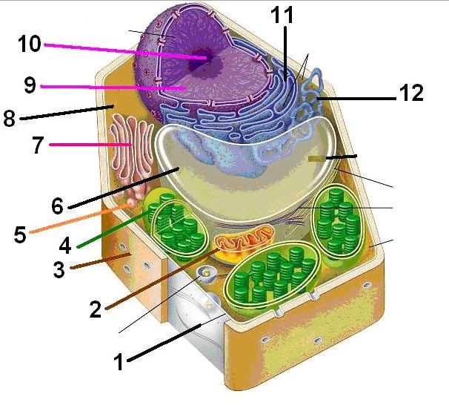
- Organelle 11 would best be described as…
- Nucleus B. Mitochondria C. Rough ER D. Golgi Complex
- Organelle 3 would best be described as…
- Nucleus B. Plasma membrane C. Cell wall D. Cell Membrane
- Organelle 6 would best be described as…
- Mitochondria B. Vacuole C. Cytoskeleton D. Plasmodesmata

- This cell is a…
- Plant cell B. Animal cell C. Prokaryote D. Virus
Identify the following molecules as either (not all answers will be used):
- Carbohydrate B. Protein C. Lipid D. Nucleic Acid

- 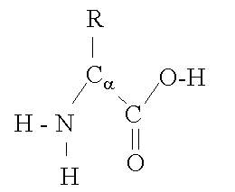 17. 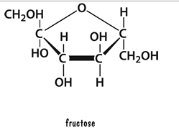

- 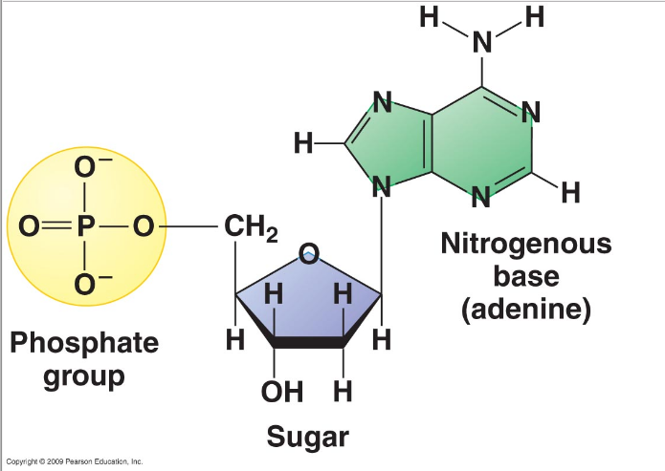18. 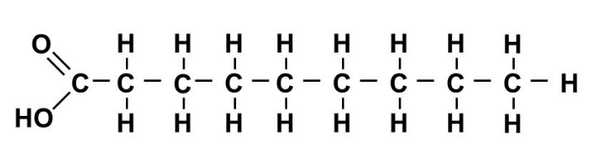

19. At high temperatures, the rate of enzyme action decreases because the increased heat
A. Changes the pH of the system
B. Alters the active site of the enzyme
C. neutralizes the acids and bases
D. Increases the concentration of the enzyme

20. A certain enzyme will hydrolyze (break down) egg white but not starch. Which statement best explains this observation?
A. Starch molecules are too large to be hydrolyzed
B. Enzyme molecules are specific in their actions.
C. Egg white acts as a coenzyme for hydrolysis.
D. Starch is composed of amino acids.

