Cell Quiz II Name: ____________________________ January 25, 2017

Use the diagram below to answer questions 1-6
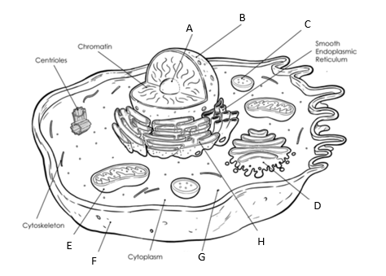

- The organelle responsible for cellular digestion?

- The organelle responsible for packaging and transporting materials out of the cell?

- The organelle responsible for breaking down glucose during cellular respiration?

- This organelle is often called the “control center of the cell”?

- Organelle F would best be described as
- Nuclear Membrane
- Cell Wall
- Plasma Membrane
- Hydro-skeleton

- Organelle G is responsible for…
- Generating lipids C. Generating polypeptides
- Generating sugars D. Generating nucleotides
- You are doing a study on an unknown cell. The tests results from your cell concluded the cell had a phospholipid bi-layer, a double membrane nucleus and lots of mitochondria. What can you predict about your unknown cell?
- Your cell is a prokaryote and could have come from a type of bacteria cell
- Your cell is a prokaryote and could have come from the gut of an animal cell
- Your cell is a eukaryote and could have come from a muscle cell from an undiscovered fish
- Your cell is a eukaryote and could have come from a fat reserve cell from a deer?

- Students are testing organic compounds in unknown solutions. A student uses Biuret to test an unknown and observed the solution turned blue throughout the solution. What can you conclude about the solution based off the students’ test?
- The solution contained lipids
- The solution contained proteins
- The solution contained starch
- The solution did not contain protein

- Enzymes are only able to perform their functions within specific temperature ranges. Temperatures above an enzyme’s range begin to break weak bonds between atoms in an enzyme. How do such changes likely prevent an enzyme from performing its function? (2pts)
- Increased temperatures bind chemical energy more strongly to the enzyme, preventing the enzyme from spreading the chemical energy to the enzyme’s substrate
- Increased temperatures transform the enzyme’s chemical energy to thermal energy, preventing the enzyme from donating the energy to the enzyme’s substrate.
- Increased temperatures change the enzyme’s 3-D structure, preventing the enzyme from interacting with the enzyme’s substrate
- Increased temperature alter the enzyme’s electrical distribution and resistivity, preventing the flow of current between the enzyme and the enzyme’s substrate.

- Which group of organic compounds includes the enzymes? (1pt)
- Protein
- Starches
- Carbohydrates
- Nucleic Acid

- Enzymes ___________ the activation energy of chemical reactions to increase reaction rate.
- Increase
- Decrease
- Freeze
- None of the answers are correct

For questions 12- 16, circle A for True and B for False

Write True or False
- Lowering the activation energy speeds the rate of chemical reactions ____________
- Lowering the activation energy changes the products ___________
- Enzymes are specific and only react with a certain type of substrate____________
- It takes the same of amount of energy to produce a reaction with and without a catalyst ___________
- Biuret turns purple in the presence of amino acids __________

Identify the following molecules as either (not all answers will be used):
- Carbohydrate B. Protein C. Lipid D. Nucleic Acid

- _______ 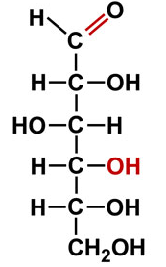 19 . __________ 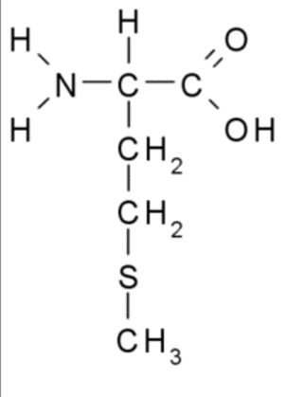

- _______ 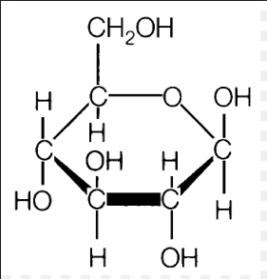 20. __________ 